

PUSL3190 Computing Project

Final Report

Cre8tify Web Application

Supervisor: Miss Dharani Rajasinghe

Name: Mahara Mahara
Plymouth Index Number: 10952728
Degree Program: BSc (Hons) Software Engineering

Acknowledgements

The successful completion of this project would not have been possible without the guidance, encouragement, and support received throughout the development process. First and foremost, sincere gratitude is extended to the project supervisor and lecturers for their valuable feedback, continuous monitoring, and professional advice provided during every stage of the research and implementation process.
Appreciation is also expressed to the faculty and university for providing the academic environment and technical resources necessary for completing this project successfully. In addition, heartfelt thanks are given to friends and peers who contributed ideas, testing feedback, and motivation during the challenging phases of development.
Special recognition is further extended to family members for their patience, encouragement, and emotional support throughout the duration of the project. Their continuous motivation played a significant role in maintaining focus and determination.
Finally, gratitude is expressed to everyone who directly or indirectly contributed to the successful completion of the Cre8tify platform and the accompanying research study.

Abstract

This project was developed in order to address the challenges faced by Sri Lankan users who use international print-on-demand platforms. These platforms require global payment methods like PayPal, not beginner-friendly and take longer time for shipping and have custom issues. As a result, local users find it hard to start or manage their own design business. After a study of existing platforms, it proved that existing platforms do not offer start-to-end free services. They lack proper localization and require paid subscriptions or a third-party integration. Designers cannot engage with customers directly through a single platform. On the customers' side, they prefer to see how a design would look on them before purchasing. But most websites don’t let you “virtually try on” a cloth. As a result, an all-in-one platform was much required for the local users. To achieve this shortcoming, a web-based platform Cre8tify, was developed to solve all these issues by being a local platform that has real-time Design Editor, free Live Preview on users’ image and a 360° Dummy Preview to enhance visualization and use Sri Lankan payment gateways. The product went through formal testing for function, usability, and performance to verify its reliability and efficiency. The test showed that all core functions performed as designed, the design editor, preview modules, and transaction flow. Users were able to create designs and purchase products with little difficulty, proving that this platform is easy to use. In addition, this platform performed steadily on multiple devices and screen sizes and loading times were reasonable under average usage. In conclusion, the results of this study have shown that a localized platform, such as Cre8tify, can successfully provide an accessible, user-friendly and practical answer to existing system limitations in the Sri Lankan market.

Keywords: custom t-shirt design, e-commerce, 360° dummy preview, localization, user-designer collaboration

Table of Contents
Acknowledgements 2
Abstract 3
Table of Contents 4
List of Figures 7
List of Tables 7
1. Introduction (1330) 8
1.1. Background 8
1.2. Problem statement 9
1.3 Aim 10
1.4 Project Objectives 10
1.4.1 Functional Deliverables 11
1.4.2 Quality Criteria and Standards 11
1.4.3 Success Metrics and Acceptance Criteria 12
1.5 Scope 12
1.6 Limitations 13
2. Literature Review (1201) 14
2.1 Introduction to Personalized E-Commerce 14
2.2 Existing Print-on-Demand Platforms – image: Comparison table 14
2.3 Interactive Visualization Technologies– image: Preview Screenshots 16
2.4 Artificial Intelligence in Apparel Visualization – image: AI workflow figure 17
2.5 Challenges in Sri Lankan E-Commerce – image: Sri lankan ecommerce stat/ chart 18
2.6 Research Gap Analysis 19
2.7 Chapter Summary 19
3. Methodology - 963 20
3.1 Introduction 20
3.2 Research and Development Approach 20
3.3 Requirement Gathering and Analysis 20
3.4 System Architecture – add system architecture diagram 21
3.5 Technology Stack Selection – technology stack table 22
3.6 Development Methodology – image : agile workflow diagram 23
3.7 Testing Strategy – testing workflow 23
3.8 Chapter Summary 25
4. SYSTEM IMPLEMENTATION AND DESIGN - 1253 25
4.1 Introduction 25
4.2 System Overview – image: Full system overview diagram 25
4.3 User Interface Design – image: Home page/ dashboard/ figma UI… 26
4.4 Authentication and Role Management – image: login page/ role based dashboard flow diagram… 26
4.5 Interactive Design Tool Implemetation – image: design tool, upload feature, layer management, text editing, preview workflow. 27
4.6 Live Preview and Visualization Modules – image: live preview, 360 dummy , preview comparison images… 28
4.7 Marketplace and Product Management – image: collection page, product detail page, favorites page.. 28
4.8 Cart and Sandbox Payment Workflow – image: cart page, payment page, success page. 29
4.9 Administrative Dashboard Features – image: admin dashboard, order page, payouts page. 29
4.10 Responsive Design Implementation – image: desktop/ mobile comparison 29
4.11 Chapter Summary 30
5. System Implementation - 998 30
5.1 Introduction 30
5.2 Frontend Implementation 31
5.3 Backend Implementation 31
5.4 Database Implementation 32
5.5 AI Integration and Visualization 33
5.6 File Handling and Image Processing 33
5.7 Security and Authentication 34
5.8 Payment and Order Processing 34
5.9 System Integration Challenges 35
5.10 Chapter Summary 35
6. Testing and Evaluation -567 35
6.1 Introduction 35
6.2 Functional Testing (Black Box Testing) 36
6.3 Usability and User Experience (UX) Testing 36
6.4 Performance Evaluation 37
6.5 Security and Validation Testing 38
6.6 Comparative Evaluation 38
6.7 Testing Challenges 39
6.8 Summary 39
7. Discussion - 485 40
7.1 Introduction 40
7.2 Advantages of the Proposed System 40
7.3 Practical Contribution to Sri Lanka 40
7.4 Technical and Operational Limitations 41
7.5 Research Contribution 41
7.6 Chapter Summary 41
8. Conclusion and Future Work - 693 42
8.1 Project Conclusion 42
8.2 Achievements of the Research 42
8.3 Future Work 43
8.4 Final Summary 43
References 44
Bibliography 45
Appendices 45
Appendix A – User Guide 45
A.1 Introduction 45
A.2 Minimum System Requirements 46
A.3 Installation Guide 46
ADD IMAGES 46
A.4 User Roles and Functionalities 46
❖ Customer 47
❖ Designer 47
❖ Administrator 47
A.5 Main Features of the System 47
ADD IMAGES 47
A.6 Troubleshooting 47
Appendix B – Project Source Code Link 48
Appendix C – GitHub Commit History 48
ADD IMAGES 48
Appendix D – Project Initiation Document (PID) 48
Appendix E – Interim Report 48
Appendix F – Records of Supervisory Meetings 49
ADD: 49
Appendix G – Other Supporting Materials 49
G.1 Preliminary Designs and Wireframes 49
ADD IMAGES 49
G.2 System Architecture and Database Design 49
ADD: 50
G.3 Testing Results and Screenshots 50
ADD IMAGES 50
G.4 Additional Interface Screenshots 50
ADD: 50

List of Figures

List of Tables

1. Introduction (1330)

1.1. Background

In the recent years, there’s a significant rise towards online shopping and personalized products. This global shift is evidenced by the custom apparel market's projected growth of over $2.45 billion by 2029, driven by increasing smartphone penetration and consumer desire for unique garments (Technavio, 2025). With that, digital platforms have become an essential medium for both consumers and creators to connect and collaborate. Mainly this occurred in the fashion industry, where individuals prefer unique designs that reflect their personal style while creative local designers wish to showcase their artworks. As a result, “Cre8tify” sits as the intersection between these trends, providing a web-based, mobile responsive e-commerce platform specially developed focusing on Sri Lankan custom apparel market, which generated over $636 million in 2024 and continues to grow at an annual rate of 15-20% (ECDB, 2024).

The rapid growth of digital commerce has significantly transformed the fashion industry, particularly in the area of personalized apparel and print-on-demand services. Modern consumers increasingly prefer products that reflect personal identity, creativity, and individual preferences rather than mass-produced items. As a result, online customization platforms have become increasingly popular worldwide.

However, despite the global success of platforms such as Printify and Redbubble, several limitations remain within the Sri Lankan market. Local designers and entrepreneurs often face difficulties related to international payment methods, expensive subscription requirements, long delivery durations, and limited product visualization capabilities.
In response to these issues, the Cre8tify platform was developed as a localized web-based marketplace designed specifically for Sri Lankan users. The system integrates interactive design customization, AI-assisted live previews, 360-degree product visualization, and a sandbox payment workflow to create a more accessible and user-friendly environment for both customers and independent designers.

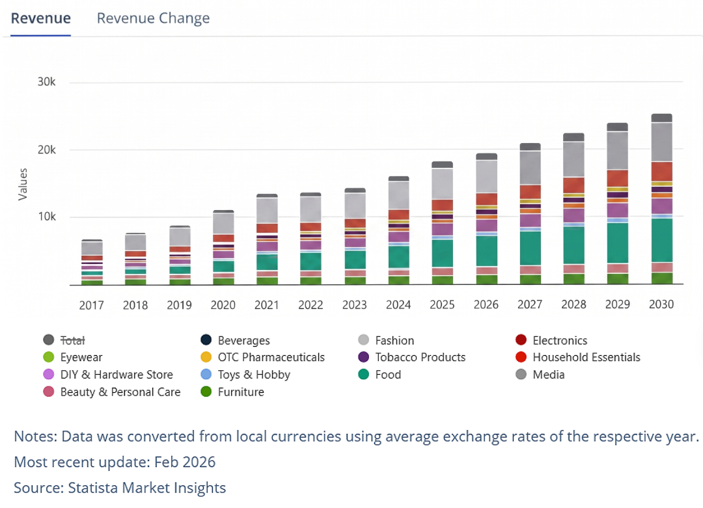
Figure 1: Global E-commerce Growth
Statistaa for charts..

1.2. Problem statement

Focusing on designing platforms, there are few existing platforms like “Printify”, “Redbubble” and “Teespring” but they lack localized features specially for beginners of our country and most of them are developed for international markets. Furthermore, Sri Lankan beginner designers face difficulties when it comes to monetizing their creativity due to payment limitations like PayPal, technical complexity and absence of beginner-friendly systems (Fernando et al., 2020; Siriwimala & Liyanage, 2021). Similarly, buyers do often lack trust and confidence when it comes to online shopping, as they cannot preview or try on them virtually. Recent studies highlight that a major obstacle to online apparel purchasing is the inability to physically inspect or try on products, which increases perceived risk (Hasan & Nguyen, 2025; Zhang et al., 2019). Therefore, these challenges highlighted the need of creating a designer-buyer friendly localized digital platform mainly focusing on Sri Lankans combining custom designing and preview functionality.
Existing global print-on-demand platforms are not fully optimized for emerging markets such as Sri Lanka. Most services depend heavily on international payment gateways, making it difficult for local users without foreign banking access to participate effectively in online commerce. Additionally, many systems provide only static product previews, which reduce customer confidence regarding the final appearance of customized apparel.
Furthermore, independent designers who wish to establish online stores often encounter financial and technical barriers, including subscription fees, complex storefront management, and the absence of localized delivery support. These limitations reduce opportunities for digital entrepreneurship within the local creative industry.

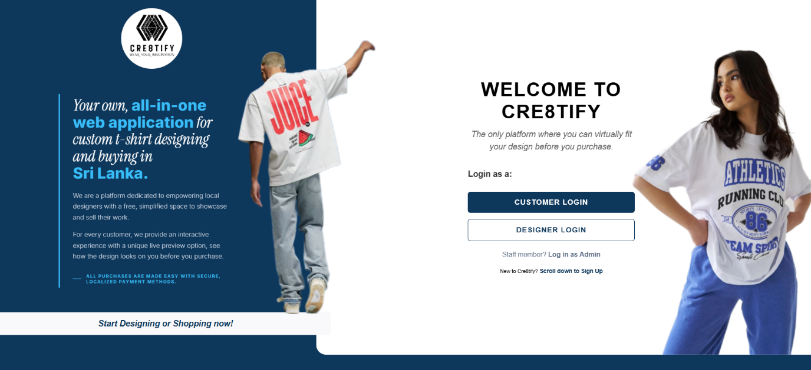
Figure 2: Cre8tify Platform Landing Page

1.3 Aim

The aim of this project was to design and develop a localized web-based custom apparel marketplace that enables Sri Lankan designers and consumers to create, visualize, and purchase personalized T-shirt products through an interactive and user-friendly platform.
The system further aimed to integrate advanced visualization technologies such as AI-assisted live previews, 360-degree product viewing, and role-based marketplace management to improve user confidence and accessibility within the local ecommerce industry.

1.4 Project Objectives
The primary objective of this research project was to design, develop, and evaluate a fully functional prototype of the “Cre8tify” web application. The platform was developed as a localized e-commerce ecosystem that supports apparel customization, interactive visualization, and online marketplace functionality for Sri Lankan designers and consumers. The system aimed to simplify the product design process while improving user confidence through advanced preview technologies and responsive user experiences.
The project objectives were categorized into functional deliverables, quality standards, and success criteria as follows.

1.4.1 Functional Deliverables
The system was designed to support a complete workflow for Customers, Designers, and Administrators through the following functional components:
- Development of an Interactive Design Tool:
To develop a browser-based T-shirt customization interface that enables users to upload graphics, add text, resize elements, rotate objects, and create personalized apparel designs without requiring professional design software.
- Implementation of a Live Preview and Visualization System:
To integrate interactive visualization features that allow users to preview apparel designs in real time. This included AI-assisted live previews using uploaded user images, as well as a 360-degree dummy preview module for realistic product inspection before purchase.
- Development of Role-Based Dashboards:
To implement secure and separate dashboard environments for Customers, Designers, and Administrators in order to manage products, portfolios, orders, approvals, and sales activities efficiently.
- Marketplace and Product Management:
To create a localized online marketplace where designers can upload products, manage pricing, publish collections, and interact with customers through an organized ecommerce workflow.
- Sandbox Payment Integration:
To simulate a secure payment and checkout process suitable for the Sri Lankan ecommerce context while avoiding dependency on international payment gateways during development and testing stages.

1.4.2 Quality Criteria and Standards
To ensure both academic and industrial quality standards, the following performance and usability objectives were established:
- Responsive Cross-Platform Accessibility:
The platform was required to function consistently across desktop, tablet, and mobile devices while maintaining a responsive and user-friendly interface.
- Performance Optimization:
The system aimed to maintain efficient loading times for design previews, visualization modules, and dashboard interactions to improve overall user experience.
- User Experience and Interface Simplicity:
The platform was designed using a user-centered approach to ensure that users could complete customization and purchasing tasks with minimal learning effort.
- Visualization Accuracy:
A key objective was to ensure that uploaded designs aligned accurately with product mockups across front, folded, and cropped preview perspectives.

1.4.3 Success Metrics and Acceptance Criteria
The success of the Cre8tify platform was evaluated using the following criteria:
- Successful Customer Workflow Completion:
Users should be able to browse products, customize apparel, preview designs, add products to the cart, and complete a simulated order process successfully.
- Designer Management Efficiency:
Designers should be able to upload products, manage their portfolios, monitor product visibility, and track sales-related activities through the dashboard system.
- Administrative Control and Moderation:
Administrators should have full control over product approvals, order monitoring, and marketplace management to ensure quality assurance within the platform.
- Preview and Visualization Reliability:
The live preview, AI fitting visualization, and 360-degree product previews should function accurately and provide realistic visual representations of customized apparel designs.

1.5 Scope

The scope of the Cre8tify platform focused on the development of a web-based custom apparel marketplace specifically designed for the Sri Lankan market. The system supports personalized T-shirt customization through interactive editing tools, mockup previews, AI-based live fitting visualization, and a simulated ecommerce transaction workflow. The platform includes separate dashboard environments for customers, designers, and administrators, allowing secure role-based interaction across the system.
The current implementation of Cre8tify platform mainly focuses on desktop-based user interaction environments while maintaining adaptability across smaller screen resolutions.

1.6 Limitations
Despite the successful implementation of the core system functionalities, several limitations remained within the current version of the platform. The AI-powered virtual try-on module depended on third-party cloud-based services, which occasionally resulted in slower response times depending on server availability and API traffic.
Due to the complexity of the interactive apparel customization interfaces, certain advanced mobile-responsive features and navigation optimizations remain limited within the current prototype implementation.
Additionally, the platform utilized a sandbox payment simulation rather than a fully integrated production payment gateway, where real financial transactions were not processed within the system.
Furthermore, the current 360-degree visualization module relied on pre-rendered product perspectives instead of real-time 3D WebGL rendering technologies. Full body-scanning and personalized avatar generation were also outside the current implementation scope.

2. Literature Review (1201)

2.1 Introduction to Personalized E-Commerce
Personalized e-commerce has transformed the modern retail industry by allowing consumers to customize products according to their individual preferences. Unlike traditional online shopping systems that offer fixed products, modern customization platforms provide interactive tools that allow users to modify colors, graphics, text, and layouts before completing a purchase. This shift toward personalization has become increasingly popular among younger digital consumers who value individuality and self-expression through fashion and lifestyle products.
In the apparel industry, print-on-demand and customization services have significantly increased in popularity due to their flexibility and low production risk. Customers are no longer limited to pre-designed garments and instead expect platforms to provide creative freedom and visualization support before making purchasing decisions. As a result, interactive e-commerce environments have become a growing research area within both software engineering and digital business industries.
Furthermore, the rapid growth of social media culture and independent creator communities has contributed to the expansion of user-generated design marketplaces. These platforms enable beginner designers and entrepreneurs to commercialize creative ideas without requiring physical stores or large startup investments.

2.2 Existing Print-on-Demand Platforms
Several international print-on-demand platforms currently dominate the global apparel customization market. Services such as Printify, Redbubble, and Teespring allow users to upload custom artwork and sell products through integrated online marketplaces. These platforms simplify production workflows by outsourcing printing, packaging, and shipping operations to third-party fulfillment providers.
Printify is widely recognized for its extensive supplier network and integration with e-commerce storefronts such as Shopify and Etsy. The platform enables users to customize apparel products and automatically connect with production partners. However, despite its flexibility, the system often requires users to create external storefronts, manage subscription-based services, and rely heavily on international payment gateways.
Similarly, Redbubble provides independent artists with opportunities to monetize artwork through a global marketplace environment. While the platform offers simplified publishing workflows, it provides limited interactive customization features for customers. Product previews are generally static and do not provide advanced visualization capabilities such as live fitting or interactive garment rotation.
Teespring and similar platforms focus primarily on campaign-based product selling rather than personalized real-time customization experiences. Most systems prioritize mass product publishing instead of user-centered visualization technologies.
Although these platforms are highly successful internationally, several challenges remain for users in developing countries such as Sri Lanka. These include difficulties related to PayPal verification, foreign currency transactions, high delivery costs, and long international shipping durations. Furthermore, many existing systems lack localization features designed specifically for regional markets and customer expectations.

Feature | Printify | Redbubble | Cre8tify
Local Payment Support | Not Available | Not Available | Fully Supported
AI-Based Live Preview | Not Available | Not Available | Available
360-Degree Product Visualization | Limited Support | Not Available | Fully Supported
Role-Based Dashboard System | Partially Available | Partially Available | Fully Supported
Localized Marketplace Features | Not Available | Not Available | Fully Supported
Real-Time Design Customization | Available | Limited Support | Fully Supported
Interactive Product Preview | Limited Support | Limited Support | Fully Supported
Support for Independent Designers | Available | Available | Fully Supported

Table Error! No text of specified style in document.-1: Comparison of Existing Print-on-Demand Platforms

2.3 Interactive Visualization Technologies
Product visualization technologies have become an important component of modern e-commerce systems, particularly within the apparel industry. Customers often hesitate to purchase clothing online because they cannot physically inspect product quality, fit, or appearance before completing transactions. To address this issue, many platforms have introduced visualization systems capable of simulating realistic product previews.
Traditional e-commerce websites primarily rely on static mockup images to display products. However, recent advancements in web technologies have enabled the development of interactive visualization systems including 360-degree viewers, augmented reality previews, and dynamic image overlays. These technologies improve customer confidence by allowing users to inspect products from multiple perspectives before purchase.
In customized apparel systems, visualization accuracy is especially important because customers expect uploaded designs to appear correctly aligned on garments. Therefore, responsive preview systems capable of maintaining realistic positioning, scaling, and cropping have become a critical research area in interactive web development.

2.4 Artificial Intelligence in Apparel Visualization
Artificial Intelligence technologies have increasingly been integrated into modern e-commerce applications to improve personalization and user interaction. In the apparel industry, AI-powered virtual fitting systems have emerged as an innovative solution for reducing uncertainty during online shopping experiences.
AI-based virtual try-on systems use advanced image processing and machine learning algorithms to simulate how garments appear on real users. These systems analyze body positioning, lighting conditions, and clothing structures to generate realistic fitting previews. Such technologies contribute significantly to improving customer confidence and reducing product return rates.
Recent advancements in deep learning models have enabled more realistic garment visualization through image synthesis and segmentation techniques. Platforms utilizing AI-assisted visualization can provide users with highly interactive shopping experiences that closely resemble physical retail environments.
Within the Cre8tify platform, AI visualization technologies were integrated to provide a localized and accessible virtual preview experience for users through image-based fitting simulations and interactive preview modules.

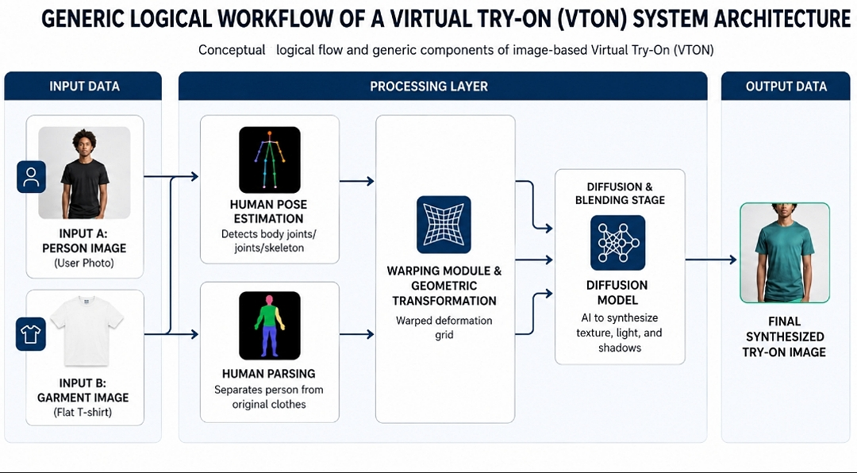
Figure 3: High-level conceptual workflow of a Virtual Try-On (VTON) system architecture.

2.5 Challenges in Sri Lankan E-Commerce

Despite the global growth of e-commerce, several technological and financial barriers continue to affect the Sri Lankan digital marketplace. Many international online platforms depend heavily on foreign banking systems and payment gateways such as PayPal and Stripe, which are not fully accessible to all local users. As a result, beginner entrepreneurs and independent designers often experience difficulties when attempting to participate in international digital commerce.
Delivery reliability and customer trust also remain major concerns within the local online shopping environment. Long shipping durations, unclear tracking systems, and inconsistent order management practices frequently reduce customer confidence in online purchases.
Additionally, many local online apparel businesses provide only limited visualization support. Customers are often required to make purchasing decisions based on static product images without the ability to preview customizations realistically. This limitation increases uncertainty regarding product appearance and overall satisfaction.
Therefore, there is a growing need for localized e-commerce systems capable of addressing these technical, financial, and usability challenges while supporting independent creators and improving customer trust within the Sri Lankan market.
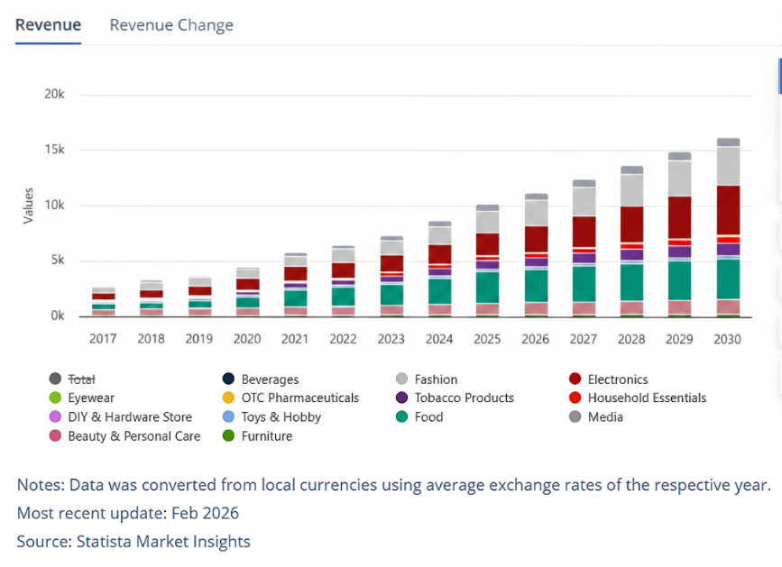
Figure 4: Sri Lankan E-Commerce Market Statistics

2.6 Research Gap Analysis

Although numerous e-commerce and print-on-demand platforms currently exist, very few systems combine localized accessibility, advanced visualization technologies, and creator-focused marketplace functionality within a single platform. Existing international systems primarily target global audiences and rarely address the practical limitations experienced by users in developing countries.
Furthermore, many existing apparel customization systems focus mainly on product publishing rather than interactive user experiences. Features such as AI-assisted live previews, responsive 360-degree visualization, and localized payment simulations remain limited or unavailable within most traditional platforms.
Current research also indicates a lack of integrated systems specifically designed to support independent Sri Lankan designers while simultaneously improving customer confidence through advanced visualization technologies. Therefore, a significant research gap exists for a localized apparel customization platform that combines e-commerce functionality, visualization accuracy, and creator accessibility within a unified environment.

2.7 Chapter Summary

This chapter reviewed existing research and technologies related to personalized e-commerce systems, print-on-demand platforms, interactive visualization technologies, and AI-assisted apparel fitting solutions. The analysis highlighted several limitations within existing global systems, particularly regarding localization, accessibility, and visualization accuracy for Sri Lankan users. Based on these findings, the need for a specialized localized platform such as Cre8tify was identified, establishing the foundation for the system design and implementation discussed in subsequent chapters.

3. Methodology - 963

3.1 Introduction

This chapter describes the methodologies, technologies, and development approaches used during the implementation of the Cre8tify platform. The project combined software engineering principles, user-centered design practices, and iterative development strategies to create a localized apparel customization and e-commerce system. The chapter further explains the system architecture, technology stack selection, requirement analysis process, and testing methodologies used to ensure system functionality, responsiveness, and usability.

3.2 Research and Development Approach
The development of the Cre8tify platform followed a research-driven software engineering approach that combined requirement analysis, prototyping, implementation, and iterative refinement. Initially, existing print-on-demand platforms and apparel customization systems were analyzed to identify technical limitations and usability gaps within the Sri Lankan market.
A user-centered design strategy was adopted throughout the project lifecycle to ensure that the platform remained intuitive and accessible for both customers and designers. Early-stage interface prototypes were created using Figma to visualize system workflows, dashboard structures, and customization environments before implementation began.
The development process further emphasized continuous testing and incremental feature enhancement, allowing the system to evolve gradually based on usability observations and technical improvements.

3.3 Requirement Gathering and Analysis

System requirements were identified through comparative analysis of existing e-commerce platforms, user expectation studies, and evaluation of customization-related challenges within online apparel marketplaces. The requirement gathering phase focused on understanding the needs of three primary stakeholder groups: customers, designers, and administrators.
Customers required an intuitive environment capable of supporting personalized apparel customization, realistic product previews, secure ordering workflows, and responsive device compatibility. Designers required dedicated portfolio management features, product publishing capabilities, and sales tracking functionalities. Administrators required centralized control over product approvals, order monitoring, and marketplace moderation.
Both functional and non-functional requirements were considered during system planning. Functional requirements included authentication systems, product customization tools, preview generation, AI-assisted visualization, cart management, and sandbox payment processing. Non-functional requirements included performance optimization, usability, scalability, and security considerations.

3.4 System Architecture
The Cre8tify platform was developed using a multi-layered full-stack architecture consisting of frontend, backend, database, and external AI integration components. This architecture was designed to ensure scalability, modularity, and maintainability throughout the system lifecycle.
The frontend layer was implemented using React.js and Vite, enabling responsive and dynamic user interfaces for apparel customization, dashboard management, and marketplace interaction. React’s component-based architecture allowed reusable UI elements and efficient rendering of highly interactive features such as live previews and product visualization modules.
The backend layer was developed using Node.js and Express.js to manage authentication, business logic, API communication, product handling, and order processing. Secure communication between frontend and backend services was established through RESTful APIs.
MongoDB was used as the primary database management system to store user information, product data, orders, favorites, and marketplace content. Additionally, external AI visualization services were integrated through API communication to support virtual try-on functionalities.
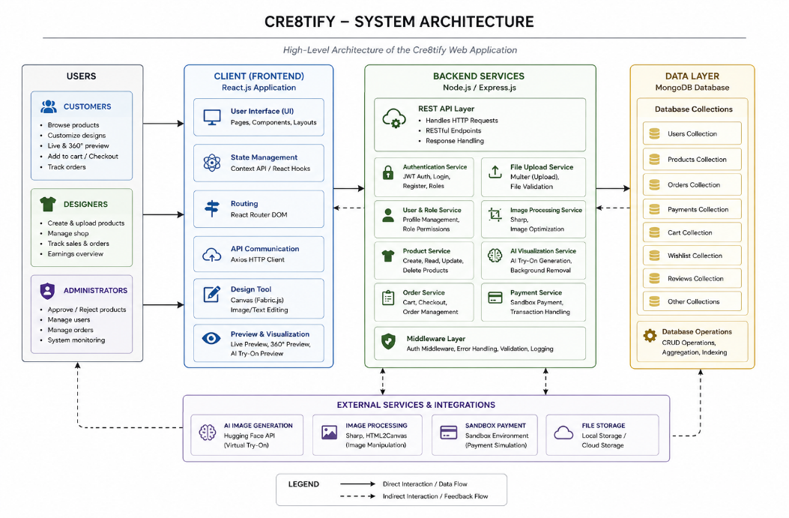

Figure 5: Cre8tify System Architecture

3.5 Technology Stack Selection
Several technologies were selected during the development process based on performance requirements, scalability considerations, and compatibility with interactive web-based applications.
- React.js
React.js was selected for frontend development due to its efficient component-based architecture and ability to handle highly interactive user interfaces. The framework enabled real-time UI updates required for design customization, preview rendering, and dashboard interactions.
- Node.js and Express.js
Node.js and Express.js were selected for backend development because of their lightweight and event-driven architecture. These technologies supported efficient API communication, asynchronous processing, and scalable request handling throughout the application.
- MongoDB
MongoDB was selected as the database management system due to its flexibility in handling large volumes of dynamic and semi-structured data. The document-oriented architecture simplified the management of products, orders, user profiles, and customization-related metadata.
- JWT Authentication
JSON Web Token (JWT) authentication was implemented to provide secure session management and role-based access control for customers, designers, and administrators.
- Figma
Figma was used during the UI/UX planning phase to develop high-fidelity prototypes and visualize responsive layouts before implementation.
- AI Integration
External AI visualization services and image-processing tools were integrated to support virtual fitting previews and realistic garment rendering functionalities.

Technology | Purpose
React.js | Frontend UI
Node.js | Backend runtime
Express.js | API handling
MongoDB | Database
JWT | Authentication
Figma | UI Prototyping

Table Error! No text of specified style in document.-1: Technology Stack

3.6 Development Methodology

The Cre8tify platform was developed using the Agile Software Development methodology. Agile was selected because it supports iterative development, continuous testing, and flexible adaptation to changing project requirements.
The project was divided into multiple development iterations focusing on different system modules such as authentication, dashboard management, product customization, AI visualization, and payment workflows. Each iteration involved planning, implementation, testing, and refinement stages.
GitHub was used as the primary version control platform to manage source code updates, feature branches, and backup repositories throughout development. Continuous integration practices were followed to ensure system stability during feature expansion and debugging phases.
The Agile methodology allowed gradual improvement of UI responsiveness, preview alignment accuracy, and marketplace workflows through repeated testing and optimization.

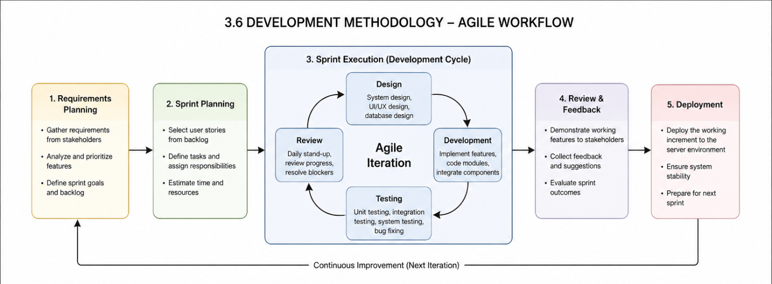
Figure 6: Agile Development Methodology

3.7 Testing Strategy
Multiple testing methodologies were applied throughout the project lifecycle to ensure functional reliability, usability, and responsive performance across different devices and workflows.
Functional testing was conducted to verify core modules including authentication systems, design customization tools, preview rendering, order management, and sandbox payment processing. Usability testing was further performed to evaluate navigation simplicity and interaction efficiency for first-time users.
Responsive styling techniques were partially implemented to maintain layout adaptability across different screen resolutions, with primary optimization focused on desktop interaction environments.

Login Module Testing
↓
Design Tool Testing
↓
Preview Generation Testing
↓
Cart & Checkout Testing
↓
Sandbox Payment Testing
↓
Admin Dashboard Testing
↓
Cross-Device Responsive Testing

Description: A simple top-down flowchart showing the stages of testing.

3.8 Chapter Summary

This chapter discussed the methodologies, technologies, and development strategies used during the implementation of the Cre8tify platform. The system combined full-stack web technologies, responsive interface design principles, AI-assisted visualization tools, and Agile development methodologies to create a localized apparel customization ecosystem. The selected technologies and architectural approaches provided the foundation for implementing the interactive features and marketplace functionalities discussed in the following chapters.

4. SYSTEM IMPLEMENTATION AND DESIGN – 1253

4.1 Introduction

This chapter discusses the implementation and interface design of the Cre8tify platform. The system was developed as a full-stack web application integrating apparel customization, visualization technologies, e-commerce workflows, and administrative management features within a single environment. The chapter explains the practical realization of the platform, including frontend interface development, backend integration, interactive preview systems, and responsive design strategies implemented throughout the project lifecycle.

4.2 System Overview
The Cre8tify platform was implemented as a localized apparel customization and e-commerce system consisting of multiple interconnected modules. The platform supports three primary user roles: Customers, Designers, and Administrators. Each role interacts with the system through dedicated dashboard environments designed according to their functional requirements.
Customers are able to browse products, customize apparel designs, preview garments through visualization modules, manage cart operations, and complete sandbox payment workflows. Designers are provided with portfolio management capabilities, product upload systems, and sales-related functionalities. Administrators are responsible for product moderation, marketplace management, and order monitoring activities.
The system architecture integrates frontend interfaces, backend services, database management, and AI-assisted visualization components to ensure smooth communication between all modules.

4.3 User Interface Design
The user interface of the Cre8tify platform was designed using a user-centered approach focusing on simplicity, responsiveness, and visual consistency. Figma prototypes were initially developed to define navigation flows, dashboard layouts, and marketplace structures before frontend implementation.
The frontend environment was developed using React.js and custom CSS styling techniques to maintain complete control over layout precision and interface responsiveness. A consistent dark-themed visual identity was implemented across dashboards and marketplace pages to provide a modern and premium user experience.
Interface components such as navigation bars, product cards, side panels, preview containers, and dashboard widgets were designed using reusable component structures to maintain consistency throughout the application.
Special attention was given to reducing user confusion within the customization workflow. Features such as drag-and-drop positioning, image scaling controls, live previews, and role-based navigation menus were designed to ensure intuitive interaction behavior even for first-time users.

4.4 Authentication and Role Management
Secure authentication and role-based access management functionalities were implemented to ensure controlled access throughout the Cre8tify platform. The system supports three primary account roles including Customers, Designers, and Administrators.
User authentication was implemented using JWT-based session management. During login, authenticated users receive secure tokens which are stored temporarily and validated during protected API requests. This approach ensures secure communication between frontend and backend services.
Separate dashboard environments were implemented for each role to maintain functional isolation and improve user experience. Customers are granted access to shopping and customization functionalities, while Designers receive product management and portfolio-related capabilities. Administrative users are provided with centralized moderation and marketplace management tools.
Additional security measures such as protected routes, session validation, and restricted access handling were implemented to prevent unauthorized interactions within sensitive system modules.

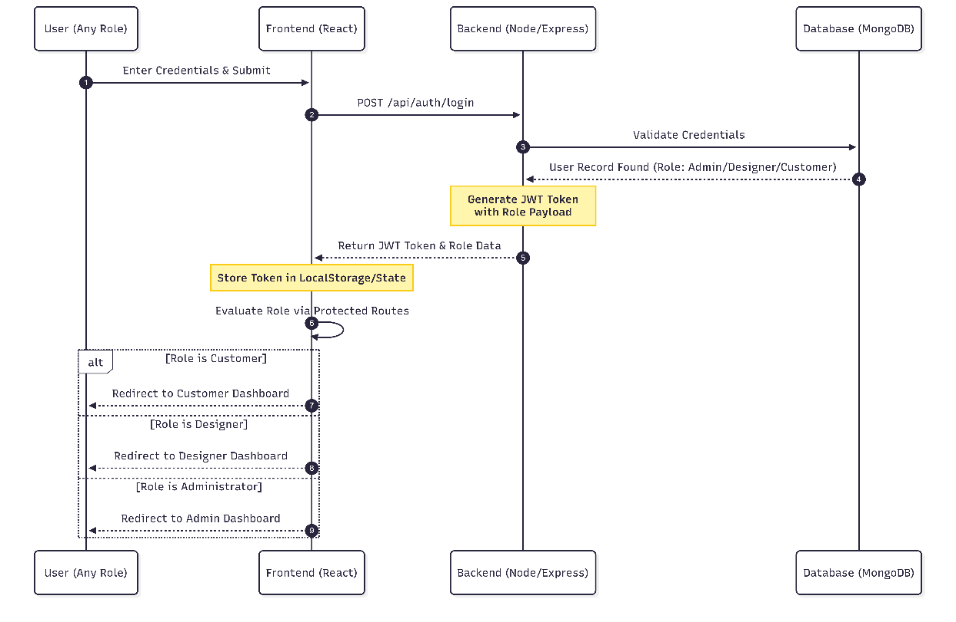
Figure 7: Sequence diagram illustrating the JWT-based authentication flow and role-based dashboard redirection logic.

4.5 Interactive Design Tool Implementation
The Interactive Design Tool represents one of the core functionalities of the Cre8tify platform. The module was developed to provide users with a browser-based apparel customization environment capable of supporting real-time editing operations without requiring external design software.
Users are able to upload custom images, insert text elements, resize objects, rotate layers, and reposition design components directly on the apparel mockup canvas. The system further supports layer management functionalities allowing elements to be brought forward or sent backward during customization processes.
The design editor was implemented using React.js state management and dynamic rendering techniques to ensure immediate visual feedback during user interactions. Uploaded design elements are rendered directly onto predefined print areas while maintaining scaling consistency and alignment boundaries.
Undo and redo state management mechanisms were implemented to improve editing flexibility and reduce accidental design loss during customization activities. Furthermore, image cropping and preview generation features were optimized to ensure accurate visualization across different mockup perspectives.
Once customization is completed, the system generates high-fidelity preview outputs mapped onto multiple apparel mockups including front view, folded view, neck view, and back view representations. These previews are then generated into snapshots and utilized during product submission workflows to preserve finalized design states and ensure consistent rendering across approval and marketplace environments.

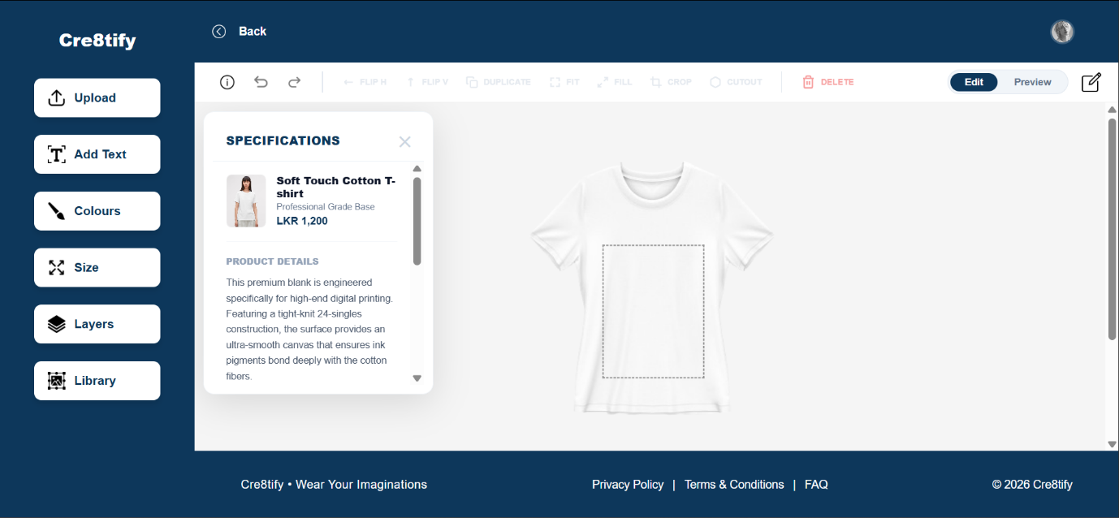
Figure 8: Design Tool Interface

Figure 9: Functional Toolbar

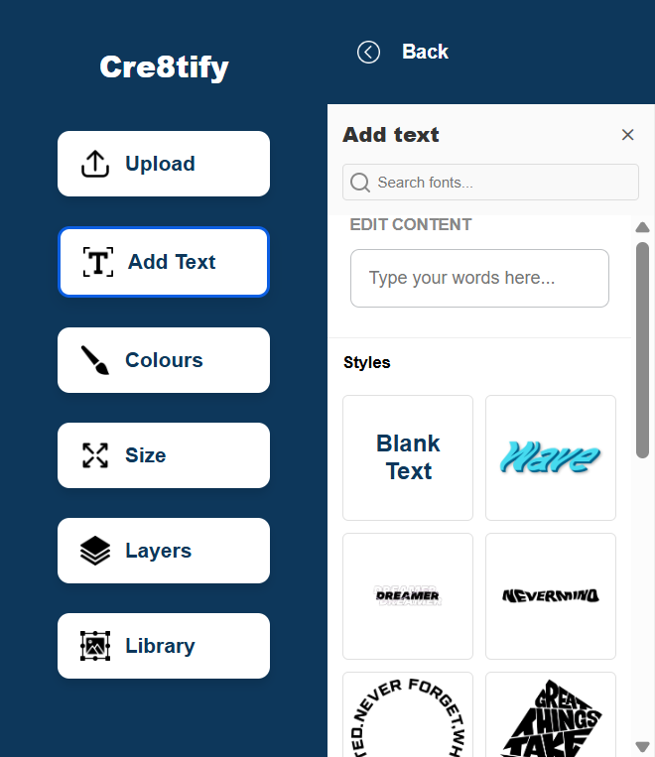

Figure 10: Design Attribute Panel: Sidebar configuration including asset uploading, typography tools, and layer management.

4.6 Live Preview and Visualization Modules
To improve customer confidence and reduce uncertainty during online purchases, the Cre8tify platform integrates advanced visualization modules including AI-assisted live previews and 360-degree dummy previews.
The Live Preview module allows users to upload personal photographs and visualize how selected apparel designs may appear when worn. External AI-assisted image processing technologies were integrated to generate realistic fitting simulations while preserving lighting consistency and garment positioning accuracy.
In addition to AI-assisted previews, a 360-degree dummy visualization system was implemented to provide interactive product inspection capabilities. Users can select gender-based dummy models and inspect apparel appearances from multiple perspectives before purchase.
The preview rendering system was carefully optimized to ensure accurate design alignment across front, folded, and cropped mockup variations. Responsive preview scaling and realistic garment positioning were prioritized throughout implementation to improve visual authenticity.
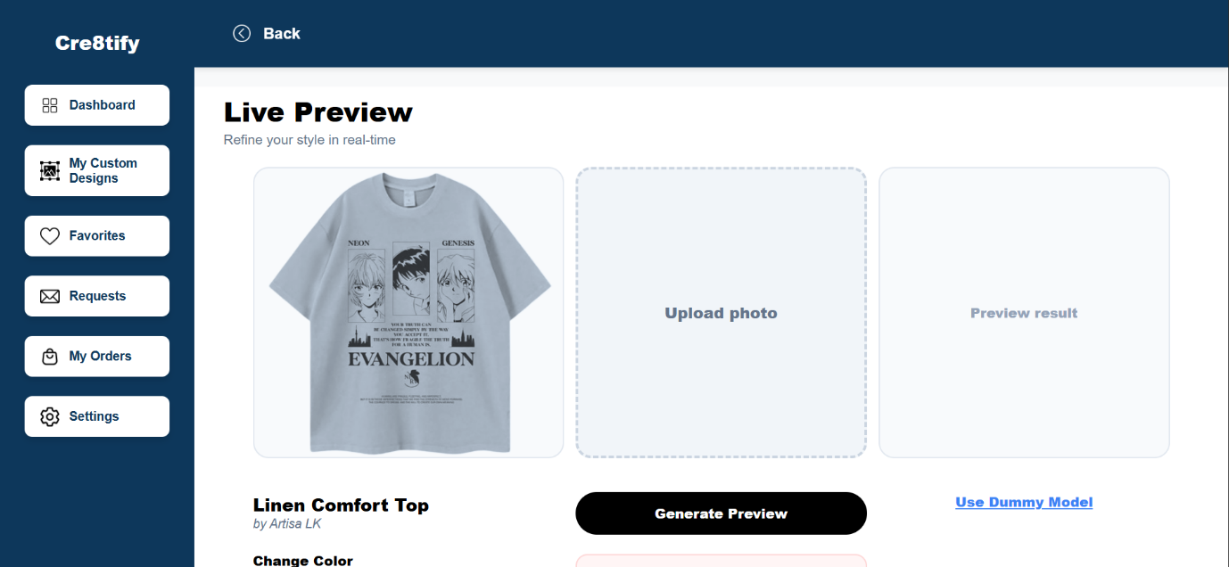
Figure 11: Live Preview

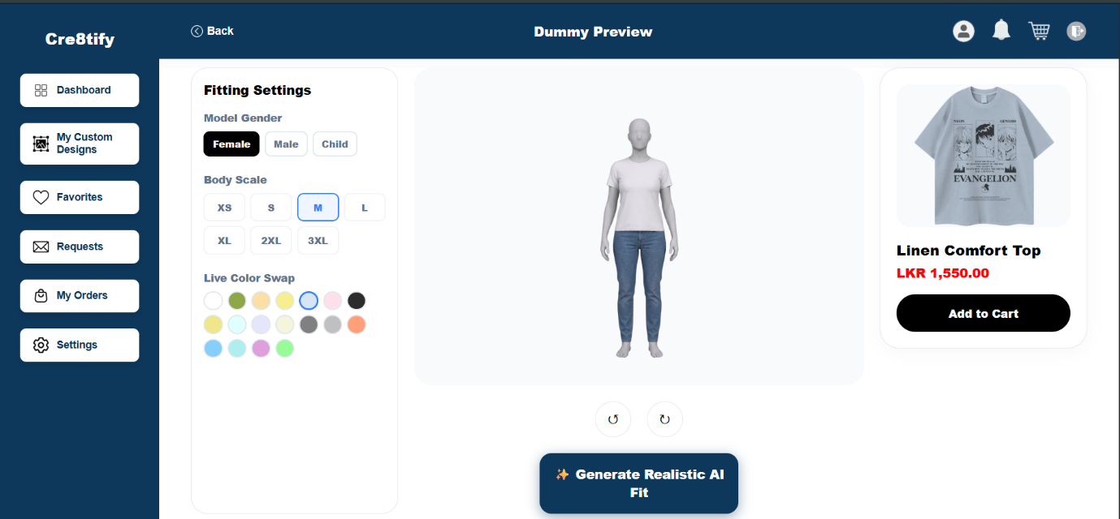

Figure 12: 360-degree Dummy Preview

4.7 Marketplace and Product Management
The marketplace module was implemented to support product publishing, browsing, and management functionalities for both customers and designers. Designers are able to upload customized products, manage pricing information, and publish apparel items directly through their dashboard environment.
Product collections were categorized into Men, Women, and Kids sections to improve browsing organization and customer navigation efficiency. Additional product filtering and favorite management functionalities were implemented to enhance shopping experiences.
The product detail workflow further integrates visualization previews, customization summaries, and purchasing functionalities within a single interface. Customers are able to review product information, preview customized apparel designs, and proceed to cart operations seamlessly.
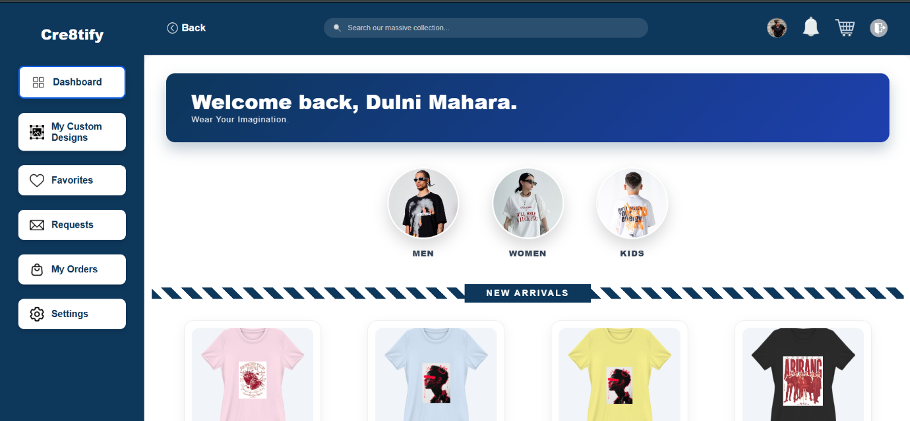

Figure 13: Cre8tify Product Collection

4.8 Cart and Sandbox Payment Workflow
The Cre8tify platform integrates a complete cart management and sandbox payment workflow to simulate real-world ecommerce transactions. Customers are able to add customized products into the cart, update quantities, manage shipping information, and proceed through a secure checkout environment.
A sandbox payment module was implemented to simulate transaction validation and order confirmation processes during development stages. The workflow updates order statuses, stores customer purchase information, and transfers order records into administrative management modules.

The payment implementation was specifically designed to support future integration with localized Sri Lankan payment gateways while currently maintaining a safe testing environment for system validation.
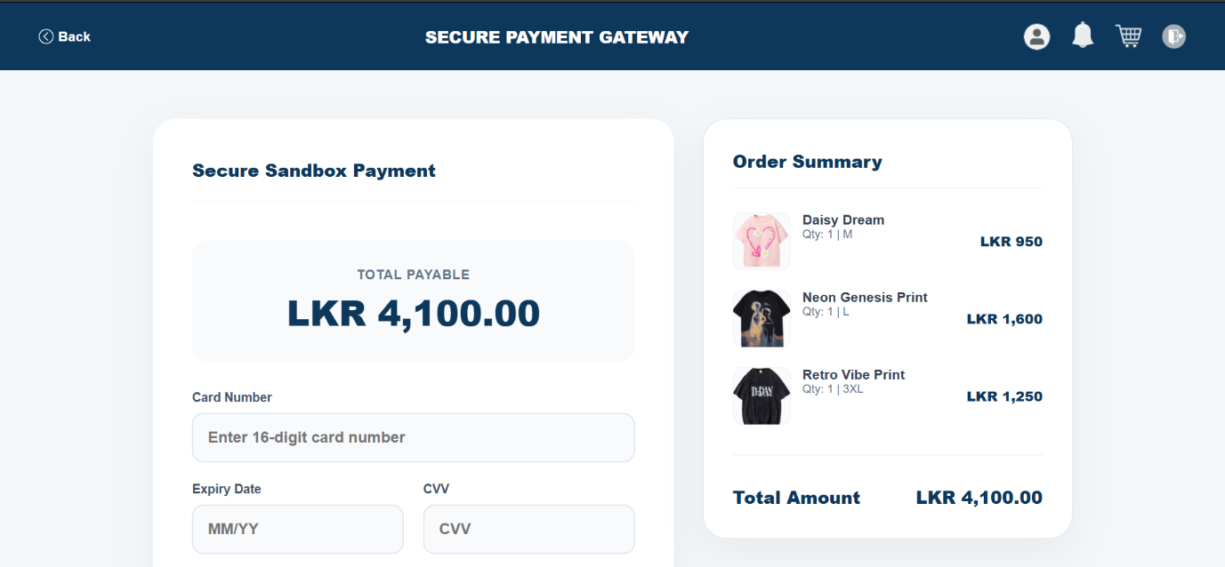
Figure 14: Sandbox Implementation

4.9 Administrative Dashboard Features
Administrative functionalities were implemented to maintain centralized control over marketplace operations and system moderation activities. The administrator dashboard enables management of products, orders, users, and financial records through organized interface modules.
Administrators are able to approve or reject submitted products, monitor customer orders, update delivery statuses, and review marketplace activities in real time. Financial monitoring features were also integrated to support earnings calculations and payout tracking processes.
Dashboard layouts were optimized using reusable component structures and responsive design techniques to maintain usability across multiple devices and screen sizes.
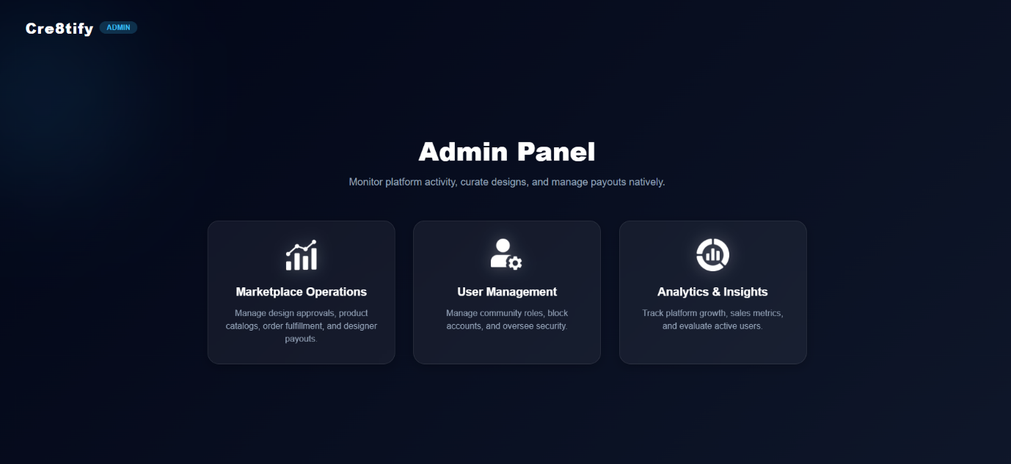

Figure 15: Admin Panel

4.10 Responsive Design Implementation
The platform interface was primarily optimized for desktop environments due to the complexity of interactive customization and visualization modules. While selected layouts adapt to varying screen dimensions, advanced mobile-specific optimizations such as fully collapsible navigation systems and touch-oriented editing workflows remain part of future enhancement plans.

4.11 Chapter Summary

This chapter discussed the implementation and interface design of the Cre8tify platform. The system integrated apparel customization technologies, visualization modules, marketplace functionalities, responsive interfaces, and administrative management systems within a unified architecture. The implemented features collectively contributed toward creating a localized and user-centered ecommerce ecosystem capable of supporting both independent designers and online consumers

5. System Implementation – 998

5.1 Introduction

This chapter discusses the technical implementation processes used during the development of the Cre8tify platform. The system combines frontend interfaces, backend services, database operations, AI-assisted visualization technologies, and secure user management functionalities within a unified architecture. The chapter further explains how individual modules communicate with each other to support apparel customization, marketplace operations, and customer interactions.

5.2 Frontend Implementation
The frontend layer of the Cre8tify platform was implemented using React.js with Vite as the build environment. React’s component-based architecture enabled efficient management of reusable interface components including navigation systems, dashboard layouts, product cards, and interactive design modules.
State management techniques were implemented to support dynamic user interactions within the Design Tool and visualization modules. Features such as live object scaling, drag-and-drop positioning, text manipulation, and preview rendering required continuous UI updates without requiring full page reloads.
Custom CSS styling was utilized instead of external UI frameworks to maintain precise control over responsiveness and layout consistency. The frontend implementation also prioritized smooth navigation flows and responsive rendering across desktop, tablet, and mobile environments.

5.3 Backend Implementation
The backend environment was developed using Node.js and Express.js to manage API communication, business logic, authentication processes, and marketplace operations. RESTful APIs were implemented to enable secure communication between frontend interfaces and database services.
The backend system manages user authentication, product uploads, order processing, image handling, payment simulations, and dashboard functionalities through modular controller-based architectures. Middleware layers were further implemented to validate requests, protect sensitive routes, and maintain secure data communication throughout the platform.
Asynchronous request handling techniques were used extensively to improve performance during image processing and AI-assisted visualization tasks. The backend architecture was designed with modularity in mind to simplify future scalability and integration of additional marketplace features.
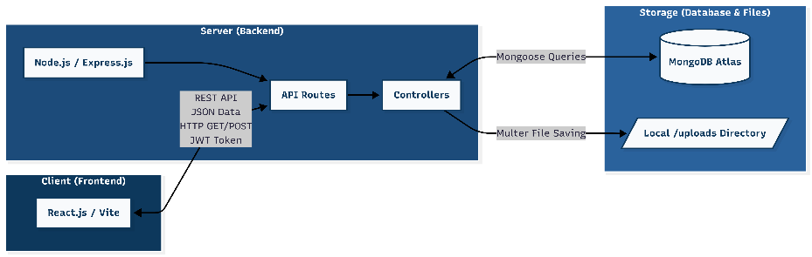

Figure 16: Client-Server Architecture

5.4 Database Implementation

MongoDB was implemented as the primary database management system for the Cre8tify platform. The document-oriented database structure enabled flexible management of dynamic marketplace data including products, orders, user accounts, favorites, and customization metadata.
Mongoose ODM was utilized to define schemas and simplify database interactions within backend services. Separate collections were implemented for customers, designers, products, orders, and administrative records to maintain organized data structures and improve query performance.
The database implementation further supports persistent storage of uploaded design assets, product preview references, payment records, and order statuses throughout the ecommerce workflow.

Collection | Purpose
users | Account management, authentication data, and role-based access control (Customer, Designer, Admin).
baseproducts | Storage of blank garment specifications, available colors, sizes, and base pricing.
designs | Storage of customized apparel data, Fabric.js canvas states, designer references, and approval statuses.
orders | Transaction records, payment methods (Sandbox/Bank), applied customization fees, and delivery statuses.
Payouts | Financial tracking for designer royalty generation and administrative payment processing.
Table Error! No text of specified style in document.-1: Core Database Collections and their Functional Purposes

Table Error! No text of specified style in document.-2:

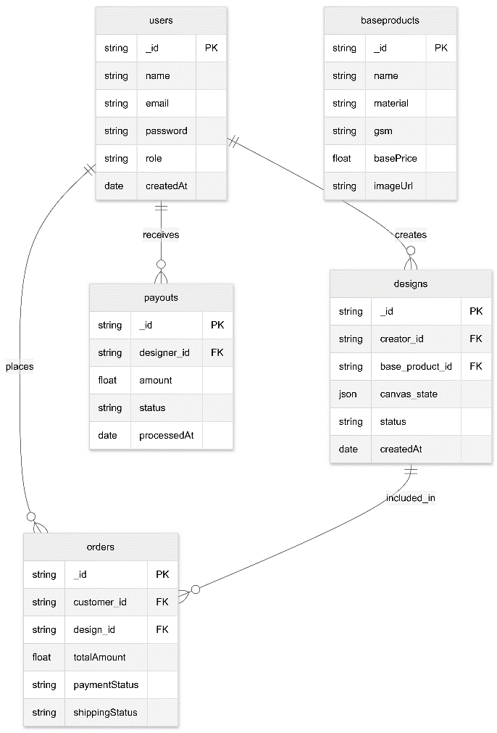

Figure 17: Entity-Relationship Diagram

5.5 AI Integration and Visualization

AI-assisted visualization technologies were integrated into the Cre8tify platform to improve customer confidence during apparel customization and purchasing activities. The Live Preview module communicates with external AI visualization services capable of generating simulated garment fitting previews using uploaded customer images.
Image processing techniques were utilized to align apparel designs realistically with body positioning, garment structures, and lighting conditions. The AI integration workflow involves image upload handling, preprocessing, API communication, preview generation, and frontend rendering stages.
In addition to AI-assisted previews, the system integrates a 360-degree dummy visualization module allowing users to inspect products from multiple perspectives before purchase. Responsive rendering techniques were implemented to maintain alignment consistency across different mockup variations including front view, folded view, and cropped neck-view representations.
These visualization technologies collectively contribute toward reducing customer uncertainty and improving realism within the online apparel customization process.

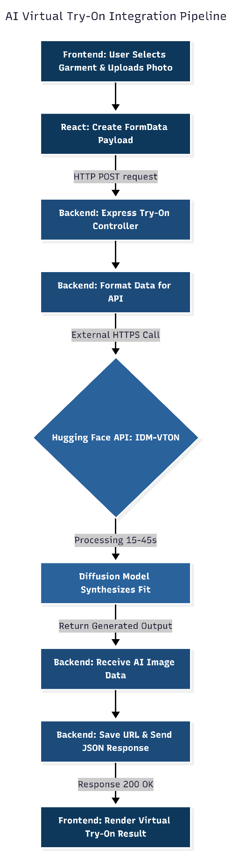

Figure 18: AI Integration Pipeline

5.6 File Handling and Image Processing
The system implements dedicated image-processing workflows to manage uploaded designs, profile images, and generated preview assets. Multer middleware was integrated within the backend environment to handle multipart image uploads securely and efficiently.
Uploaded files are processed and stored using optimized filesystem management techniques rather than directly storing large image data inside the database. This implementation significantly reduced payload sizes and improved overall system performance during preview rendering and marketplace loading operations.
To maintain preview consistency throughout the product submission workflow, the system generates rendered snapshot representations of customized apparel designs before transferring them between marketplace modules. This approach minimizes rendering inconsistencies and preserves design positioning accuracy during product approval and display processes.
Additional image-processing utilities were further utilized to resize uploaded assets, preserve aspect ratios, and generate optimized preview outputs suitable for responsive web rendering.

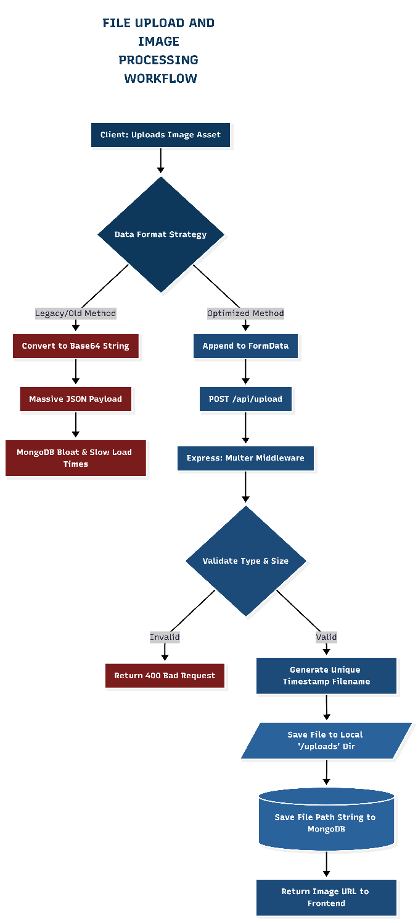

Figure 19: File Upload Workflow

5.7 Security and Authentication
Security mechanisms were implemented throughout the platform to protect user information and maintain controlled system access. JWT-based authentication was integrated to manage secure login sessions and role validation processes for customers, designers, and administrators.
Protected route mechanisms were implemented to prevent unauthorized access to dashboard functionalities and administrative operations. Middleware validation layers further verify user roles before granting access to restricted modules.
Passwords and sensitive account information were securely processed during authentication workflows. Session validation and token-based authorization collectively contribute toward maintaining secure communication between frontend and backend services.

5.8 Payment and Order Processing
The Cre8tify platform integrates a sandbox-based payment workflow designed to simulate real-world ecommerce transactions within a safe testing environment. Customers are able to review products, manage shipping information, and proceed through order confirmation stages before completing simulated payment validation.
The order-processing system updates transaction statuses dynamically throughout the workflow, allowing administrators to monitor order progress and delivery stages through dedicated dashboard interfaces.
The payment workflow was intentionally structured to support future integration with localized Sri Lankan payment gateways such as PayHere and Stripe. This implementation provides scalability opportunities for transforming the prototype into a fully commercialized platform.

5.9 System Integration Challenges

Several technical challenges were encountered during the implementation of the Cre8tify platform. One major challenge involved maintaining accurate alignment between uploaded designs and multiple apparel mockups during responsive preview rendering.
Additional complexity arose during AI-assisted visualization integration due to dependency on external API services and varying response durations during image-generation tasks. Performance optimization strategies were therefore implemented to reduce loading delays and maintain stable user experiences.
Browser responsiveness and cross-device compatibility also required extensive refinement, particularly for high-interaction modules such as the Design Tool and Preview environments. Image scaling inconsistencies and mockup rendering differences between desktop and mobile environments were gradually optimized through iterative testing and UI adjustments.
Despite these challenges, the system successfully achieved stable integration across all major platform modules.

5.10 Chapter Summary

This chapter discussed the technical implementation processes used during the development of the Cre8tify platform. Frontend interfaces, backend services, database structures, AI-assisted visualization systems, authentication mechanisms, and payment workflows were collectively integrated to support the platform’s apparel customization and ecommerce functionalities. The implemented architecture provided a scalable and responsive foundation for supporting localized digital commerce activities.

6. Testing and Evaluation -567

6.1 Introduction

This chapter discusses the testing and evaluation procedures conducted during the development of the Cre8tify platform. Multiple testing methodologies were applied to verify system functionality, usability, responsiveness, and workflow stability across the implemented modules. The evaluation process focused on validating apparel customization features, visualization systems, authentication workflows, marketplace operations, and order-processing functionalities. The chapter further analyzes system performance and compares the proposed platform against existing print-on-demand solutions.

6.2 Functional Testing (Black Box Testing)
Functional testing was conducted to verify whether all core modules of the Cre8tify platform operated according to the specified requirements. Individual system components including authentication, product customization, preview rendering, dashboard management, and sandbox payment workflows were tested independently before integrated system evaluation.
Authentication testing verified secure login validation, protected route handling, and role-based dashboard access for Customers, Designers, and Administrators. Product customization testing focused on validating image uploads, text editing, layer positioning, scaling controls, and preview generation processes within the Design Tool.
Additional testing procedures were conducted to ensure correct order creation, cart management, payment confirmation, and product approval workflows. Generated preview snapshots were also evaluated to confirm consistent rendering across marketplace modules and approval environments.

Test ID | Feature Under Test | Input / Action | Expected Observable Outcome | Result
FT-01 | User Authentication | Submit valid login credentials. | JWT token issued, session created, and user routed to their specific role-based Dashboard. | Pass
FT-02 | Interactive Design Canvas | Drag and drop an image layer across the workspace. | Image layer smoothly repositions and anchors visually to the new canvas coordinates. | Pass
FT-03 | Layer Z-Index Management | Click the "Move to Front" control on a background element. | The selected design element successfully overlaps all other existing layers on the canvas. | Pass
FT-04 | AI Virtual Try-On Engine | Upload a valid front-facing user photograph. | System processes the image via API and successfully renders a realistic synthesized fitting. | Pass
FT-05 | Sandbox Checkout Workflow | Submit simulated Sandbox payment details. | Transaction validated, order status updates to "Paid," and the record appears in the Admin panel. | Pass
FT-06 | Administrative Moderation | Click "Reject" on a pending designer submission. | Design status updates to rejected and is immediately removed from the public marketplace view. | Pass

Table Error! No text of specified style in document.-1: Functional black-box testing scenarios and results for core system modules.

6.3 Usability and User Experience (UX) Testing
Usability testing was performed to evaluate how effectively users could interact with the platform without external guidance. The testing process involved peer-based evaluations focusing on navigation simplicity, interface clarity, customization workflows, and overall interaction experience.
Participants were asked to complete common tasks such as creating customized apparel designs, previewing products, managing cart operations, and completing sandbox purchase workflows. Observations indicated that users were generally able to complete these tasks successfully with minimal confusion. Particular attention was given to the Design Tool interface since it represented the most interaction-intensive module within the system.
To quantify these observations, participants were asked to rate their experience on a scale of 1 to 5 (1 being Very Difficult, 5 being Very Easy). As illustrated in Figure 20, standard e-commerce flows scored highly, while the Interactive Design Tool received a slightly lower, yet acceptable, rating reflecting the natural learning curve associated with layer-based canvas manipulation.

Figure 20: Average usability ratings for core system tasks (5-point scale)

6.4 Performance Evaluation
Performance evaluation procedures were conducted to analyze system responsiveness, rendering stability, and loading efficiency during high-interaction operations. The evaluation primarily focused on preview generation workflows, dashboard navigation, image uploads, and marketplace loading behaviors.
Optimization techniques such as local filesystem image handling and lightweight API communication were implemented to reduce payload sizes and improve rendering speed during marketplace operations. Snapshot-based preview handling further improved consistency during product submission workflows.
The platform demonstrated stable performance under standard desktop interaction conditions. Interactive modules including the Design Tool and preview systems maintained acceptable responsiveness during testing stages. However, performance variations were occasionally observed during external AI-assisted visualization requests due to dependency on third-party API response times.

Evaluation Area | Technical Observation & System Response
Page & Marketplace Loading | Sub-second initial load times achieved post-migration from Base64 to local filesystem image storage.
Interactive Design Rendering | Real-time React state updates with zero observable latency during layer manipulation, drag-and-drop, and object scaling.
Snapshot Preview Generation | High-fidelity mockups generated consistently within 1-2 seconds using html2canvas without blocking the main browser thread.
AI Virtual Try-On Visualization | Asynchronous processing completed within 15-45 seconds, dependent on third-party Hugging Face API server availability and traffic.
Dashboard Navigation | Instantaneous client-side routing utilizing react-router-dom with optimized state hydration.

Table Error! No text of specified style in document.-1: Summary of system performance evaluation

6.5 Security and Validation Testing
Security and validation testing were conducted to ensure secure handling of user information and protected access to sensitive system functionalities. Authentication workflows were evaluated to verify JWT-based session validation and protected route implementation.
Role-based access control mechanisms were tested to ensure Customers, Designers, and Administrators could only access authorized modules within the system. Additional validation testing was further performed to reduce invalid form submissions and unauthorized API interactions.
File-upload validation mechanisms were also implemented to restrict unsupported image formats and improve overall system stability during image-processing operations.

6.6 Comparative Evaluation

A comparative evaluation was conducted between the Cre8tify platform and existing print-on-demand systems such as Printify and Redbubble. The comparison focused on localization support, customization flexibility, visualization features, and accessibility for Sri Lankan creators.

Unlike global platforms that require external storefront creation and international payment verification, Cre8tify provides a localized “straight-to-shop” workflow allowing designers to publish products directly without requiring external ecommerce integration.
The system further differentiates itself through the implementation of AI-assisted live previews and 360-degree visualization modules, features not commonly accessible within localized Sri Lankan apparel marketplaces.

Additionally, sandbox-based localized transaction workflows and future compatibility with local payment gateways improve accessibility for users who face limitations with international payment infrastructures.

Evaluation Feature | Cre8tify | Printify | Redbubble
Localized Workflow & Storefront | Fully integrated "straight-to-shop" marketplace requiring zero external setup. | Requires integration with external e-commerce platforms (e.g., Shopify, WooCommerce). | Centralized global marketplace, but lacks regional localization.
AI-Powered Live Virtual Try-On | Integrated image-based fitting simulations via Hugging Face API. | Not available; relies on static 2D mockups. | Not available; relies on static 2D mockups.
Interactive Visualization | Fully supported multi-angle 360-degree interactive viewing. | Limited to static multi-angle images. | Limited to static multi-angle images.
Local Payment Adaptability | Sandbox validation designed specifically for local gateways (e.g., Bank Transfer, PayHere). | Highly dependent on international gateways (PayPal/Stripe). | Restricted strictly to international payment providers.
Designer Publishing & Control | Direct localized publishing with built-in portfolio and royalty tracking. | Partial; prioritizes merchant supply over direct designer-to-consumer sales. | Supported (artist-focused), but highly saturated on a global scale.

Table Error! No text of specified style in document.-1: Comparative evaluation of system features between Cre8tify and existing global print-on-demand platforms.

6.7 Testing Challenges

Several challenges were encountered during the testing and evaluation stages of the project. One major difficulty involved maintaining accurate alignment consistency between uploaded designs and multiple apparel mockup variations during responsive rendering processes.
Additional limitations were observed during AI-assisted visualization generation due to variable response durations from external API services. These delays occasionally affected preview-generation speed during intensive testing sessions.
Cross-device layout consistency also required repeated refinement due to the complexity of highly interactive design interfaces. As a result, the current implementation primarily focuses on stable desktop-based interactions while maintaining limited adaptability for selected smaller screen environments.

6.8 Summary

This chapter discussed the testing methodologies and evaluation procedures conducted during the development of the Cre8tify platform. Functional testing, usability evaluation, security validation, and comparative analysis collectively demonstrated that the system successfully supports apparel customization, visualization, and ecommerce workflows within a localized digital marketplace environment. The findings further highlight the platform’s potential contribution toward improving accessibility for independent creators within Sri Lanka’s growing digital commerce landscape.

7. Discussion - 485

7.1 Introduction

This chapter discusses the broader significance, practical contributions, and limitations of the Cre8tify platform. The discussion evaluates how the proposed system addresses limitations observed in existing print-on-demand services while contributing toward localized digital commerce accessibility within Sri Lanka.

7.2 Advantages of the Proposed System

The Cre8tify platform provides several advantages compared to conventional print-on-demand systems currently accessible to Sri Lankan users. One major advantage is the implementation of a localized “straight-to-shop” workflow that allows independent designers to upload and publish customized apparel products without requiring external storefront management or initial investment.
The platform further improves user confidence through the integration of AI-assisted live previews and 360-degree visualization modules. These features allow customers to visualize products more realistically before purchase, reducing uncertainty commonly associated with online apparel shopping.
Unlike global systems that rely heavily on international payment verification processes, the platform was designed with localized adaptability in mind. The implementation of sandbox-based localized transaction workflows creates a foundation for future integration with Sri Lankan banking infrastructures and payment gateways.
Additionally, centralized product moderation and administrative approval systems contribute toward maintaining marketplace quality and trustworthiness.

7.3 Practical Contribution to Sri Lanka

The implementation of the Cre8tify platform demonstrates how localized ecommerce technologies can improve accessibility for independent creators and digital entrepreneurs within Sri Lanka. Many beginner designers face financial and technical barriers when attempting to utilize international print-on-demand services due to payment verification restrictions, international transaction requirements, and storefront management complexities.
The proposed platform reduces these barriers by providing a simplified environment where users can create, customize, preview, and publish products within a single ecosystem. This approach encourages participation in digital entrepreneurship without requiring significant startup investment.
The system also contributes toward improving customer trust within localized online shopping environments through transparent preview systems, order tracking workflows, and centralized administrative moderation functionalities.
The motivation for this research was partially influenced by the researcher’s own experiences encountering accessibility limitations and payment-related restrictions while attempting to explore international apparel design marketplaces as an undergraduate creator.

7.4 Technical and Operational Limitations

Despite the successful implementation of the Cre8tify platform, several limitations remain within the current prototype. One limitation involves dependency on external AI visualization services, which may introduce response delays and service availability constraints during preview-generation processes.
Additionally, the current implementation primarily focuses on desktop-oriented interaction environments due to the complexity of highly interactive apparel customization modules. Advanced mobile-specific navigation systems and fully optimized touch-based editing interactions remain part of future enhancement plans.
The visualization system also currently relies on standardized garment mockups and generated preview snapshots rather than fully dynamic 3D body-scanning technologies. While this approach improves rendering consistency and performance, further personalization capabilities remain possible for future development stages.

7.5 Research Contribution

This research contributes toward the growing field of localized ecommerce and apparel customization technologies by demonstrating how AI-assisted visualization systems, interactive customization environments, and role-based marketplace architectures can be integrated into a unified digital platform tailored for regional accessibility needs.
The project further highlights the importance of adapting global ecommerce concepts to local economic and technological conditions rather than directly replicating international business models. The findings demonstrate that localized digital platforms can create more accessible opportunities for independent creators while improving customer trust and interaction experiences.

7.6 Chapter Summary

This chapter discussed the practical significance, advantages, and limitations of the Cre8tify platform. The findings indicate that localized apparel customization ecosystems can improve accessibility for independent designers while addressing several limitations present within existing international print-on-demand services. The discussion further highlighted areas for future improvement and potential opportunities for expanding the platform into a fully commercialized digital marketplace.

8. Conclusion and Future Work - 693

8.1 Project Conclusion

This research successfully designed and implemented the Cre8tify platform as a localized apparel customization and ecommerce ecosystem tailored for the Sri Lankan digital marketplace environment. The project integrated interactive customization technologies, AI-assisted visualization systems, role-based dashboard architectures, and sandbox transaction workflows within a unified full-stack web application.
The implementation demonstrated that localized ecommerce platforms can overcome several barriers commonly encountered within international print-on-demand services, particularly those related to payment accessibility, storefront management complexity, and limited visualization capabilities.
Through the integration of live preview systems, 360-degree visualization modules, and centralized marketplace moderation, the platform improved both customer interaction experiences and designer accessibility. The project further emphasized the importance of adapting ecommerce technologies according to local economic and technological conditions rather than relying entirely on global platform structures.
Overall, the research achieved its primary objectives and established a strong foundation for future expansion into a fully commercialized apparel customization ecosystem.

8.2 Achievements of the Research

Several major objectives were successfully achieved during the development of the Cre8tify platform. The project successfully implemented a browser-based apparel customization environment supporting image uploads, text editing, layer management, and real-time preview generation functionalities.
AI-assisted visualization modules and 360-degree dummy preview systems were further integrated to improve customer confidence during purchasing workflows. Additionally, role-based dashboards for Customers, Designers, and Administrators were implemented successfully to support marketplace management and product moderation activities.
The platform also achieved stable integration between frontend interfaces, backend services, database management systems, and image-processing workflows while maintaining responsive desktop-oriented interaction environments.

Core Project Objective | Implementation Status & Key Achievements
Interactive Design Tool | Completed: Fully developed browser-based canvas supporting image uploads, text manipulation, layer Z-index management, and real-time snapshot rendering.
Live Preview & Visualization | Completed: Successfully integrated Hugging Face IDM-VTON API for AI-assisted virtual try-on, alongside a responsive 360-degree interactive dummy viewer.
Role-Based Dashboard System | Completed: Implemented secure, JWT-authenticated routing providing distinct, isolated dashboard environments for Customers, Designers, and Administrators.
Sandbox Payment Workflow | Completed: Developed a complete end-to-end cart management and checkout pipeline with simulated transaction validation for localized ecommerce testing.
System & Database Optimization | Completed: Achieved stable MERN stack integration and successfully optimized backend performance by migrating image handling to local filesystem storage via Multer.

Table Error! No text of specified style in document.-1: Summary of project objectives and implementation achievements.

8.3 Future Work

Although the current implementation successfully satisfies the primary objectives of the research, several improvements and expansions remain possible for future development.
One major enhancement involves the implementation of fully optimized mobile-responsive interaction environments and touch-oriented customization workflows. Future iterations may also integrate advanced WebGL-based 3D garment rendering technologies using frameworks such as Three.js to provide more realistic spatial visualization capabilities.
Additional improvements may further include integration with localized production payment gateways such as PayHere and Stripe to support real-world financial transactions within Sri Lanka.
Future development could also involve deployment of dedicated AI visualization services on cloud GPU infrastructures to reduce latency and improve generation stability during live preview operations.
Furthermore, personalized body-scanning technologies and avatar-based fitting systems may significantly improve realism and reduce apparel sizing uncertainties during online shopping experiences.

8.4 Final Summary

In conclusion, the Cre8tify platform demonstrates the potential of localized ecommerce technologies to improve accessibility for independent creators while enhancing online apparel customization experiences. The research successfully combined customization tools, visualization technologies, and marketplace functionalities within a unified digital ecosystem tailored for Sri Lankan users. The findings further provide a foundation for future advancements in localized AI-assisted ecommerce platforms and digital entrepreneurship systems.

References
Technavio (2025) Custom Apparel Market Analysis Report 2025–2029. Available at: https://www.technavio.com/ (Accessed: 10 September 2025).
ECDB (2024) Fashion – Sri Lanka eCommerce Market Analysis. Available at: https://ecommercedb.com/markets/lk/fashion (Accessed: 10 September 2025).
Özbek, V. (2020) ‘Consumer dissatisfaction in online apparel shopping due to static product visualization’, International Journal of Fashion Technology, 8(2), pp. 44–58.
Liu, Y. and Wang, T. (2024) ‘MYCloth: Intelligent 3D Garment Visualization for Interactive Online Shopping’, Journal of Virtual Commerce Systems, 12(1), pp. 55–73.
Fernando, K., Perera, M. and Silva, R. (2020) ‘Digital Payment Barriers in Sri Lankan Small and Medium Enterprises’, Sri Lankan Journal of Business Innovation, 5(3), pp. 18–29.
Siriwimala, P. and Liyanage, D. (2021) ‘E-commerce Accessibility Challenges in Sri Lanka’, Asian Journal of Digital Economy, 4(1), pp. 66–81.
Hasan, R. and Nguyen, P. (2025) ‘Consumer Trust and Virtual Try-On Systems in Online Fashion Retail’, International Journal of Interactive Commerce, 11(2), pp. 90–108.
Zhang, Q., Lee, H. and Chen, Y. (2019) ‘Reducing Buyer Risk in Online Apparel Shopping through Interactive Visualization’, Electronic Commerce Research Journal, 19(4), pp. 201–219.
React.dev (2025) React Documentation. Available at: https://react.dev/ (Accessed: 10 September 2025).
Node.js Foundation (2025) Node.js Documentation. Available at: https://nodejs.org/en/docs/ (Accessed: 10 September 2025).
MongoDB Inc. (2025) MongoDB Documentation. Available at: https://www.mongodb.com/docs/ (Accessed: 10 September 2025).
Express.js (2025) Express Framework Documentation. Available at: https://expressjs.com/ (Accessed: 10 September 2025).
Auth0 (2026) JSON Web Token Introduction. Available at: https://jwt.io/introduction/ (Accessed: 03 March 2026).
Hugging Face (2025) Hugging Face AI Platform. Available at: https://huggingface.co/ (Accessed: 10 September 2025).
Printify (2025) Printify Official Website. Available at: https://printify.com/ (Accessed: 10 September 2025).
Redbubble (2025) Redbubble Official Website. Available at: https://www.redbubble.com/ (Accessed: 10 September 2025).
html2canvas (2025) html2canvas Documentation. Available at: https://html2canvas.hertzen.com/ (Accessed: 10 September 2025).
Figma (2025) Figma Design Platform. Available at: https://www.figma.com/ (Accessed: 10 September 2025).
Multer (2025) Multer Middleware for Node.js. Available at: https://github.com/expressjs/multer (Accessed: 10 September 2025).
Sharp (2025) Sharp Image Processing Library. Available at: https://sharp.pixelplumbing.com/ (Accessed: 10 September 2025).

Bibliography
Norman, D. (2013) The Design of Everyday Things. Revised edn. New York: Basic Books.
Nielsen, J. (1994) Usability Engineering. San Francisco: Morgan Kaufmann.
Krug, S. (2014) Don’t Make Me Think: A Common Sense Approach to Web Usability. 3rd edn. Berkeley: New Riders.
Pressman, R.S. and Maxim, B.R. (2020) Software Engineering: A Practitioner’s Approach. 9th edn. New York: McGraw-Hill Education.
Laudon, K.C. and Traver, C.G. (2021) E-Commerce: Business, Technology, Society. 17th edn. Pearson Education.

Appendices

Appendix A – User Guide

A.1 Introduction

The following user guide explains how the Cre8tify platform can be installed, configured, and operated for demonstration purposes. The guide outlines the minimum software and hardware requirements, installation procedures, and operational workflows necessary to access the platform functionalities successfully.

A.2 Minimum System Requirements

Component | Requirement
Operating System | Windows 10 / 11
Processor | Intel Core i5 or equivalent
RAM | Minimum 8GB
Storage | 256GB SSD Recommended
Browser | Google Chrome
Node.js | v18+
Database | MongoDB Atlas / Local MongoDB
IDE | Visual Studio Code

Table A 1: System Requirement

A.3 Installation Guide
The Cre8tify platform utilizes a MERN-stack architecture consisting of React.js, Node.js, Express.js, and MongoDB. The following procedure should be followed to execute the application successfully.
- Clone the GitHub repository locally.
- Open the project folder using Visual Studio Code.
- Install frontend and backend dependencies using the npm install command.
- Configure the required environment variables, including MongoDB URI and JWT secret keys.
- Start the frontend development server using npm run dev.
- Start the backend server using npm start.
- Open the localhost URL generated by Vite in Google Chrome

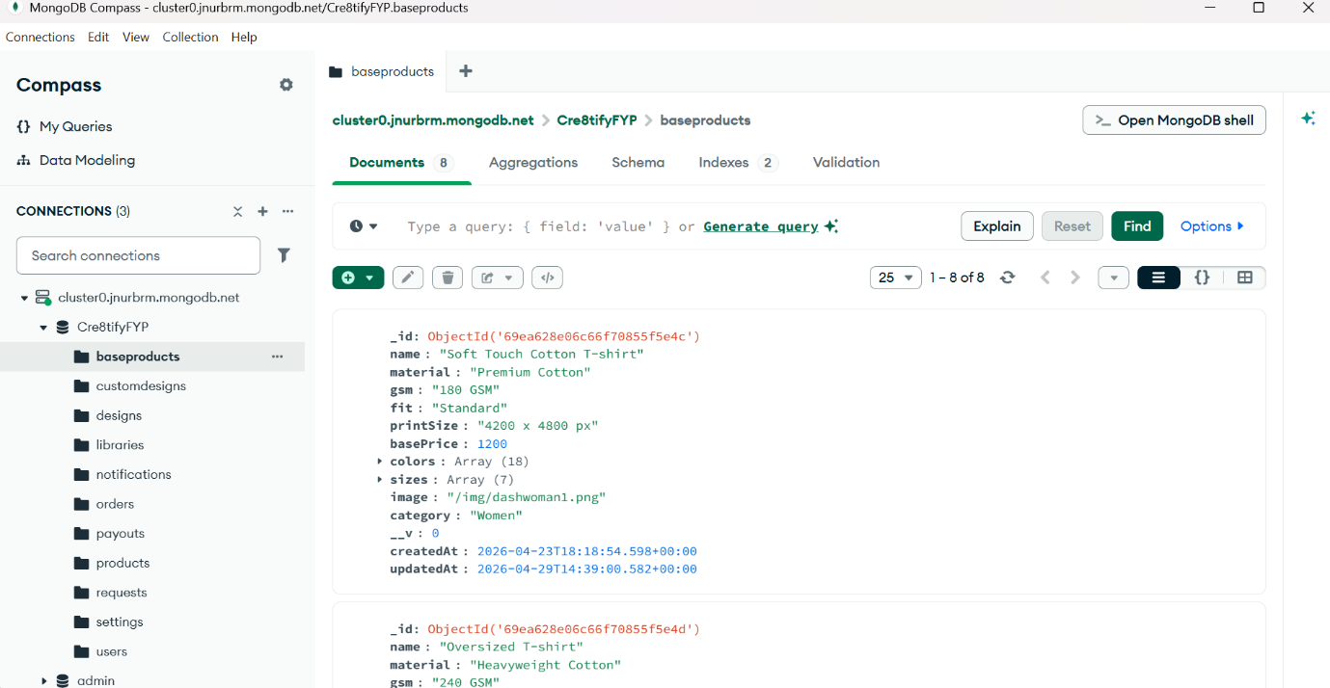
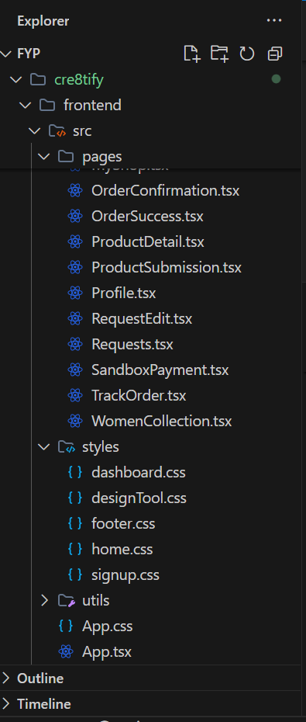
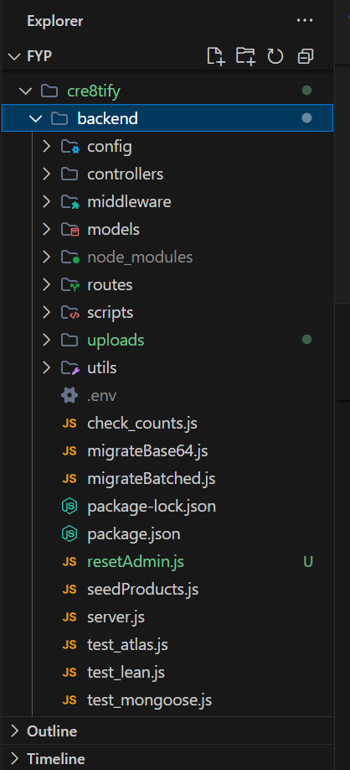
Figure A 1: VS Code Project Structure
Figure A 2: MongoDB Atlas Structure
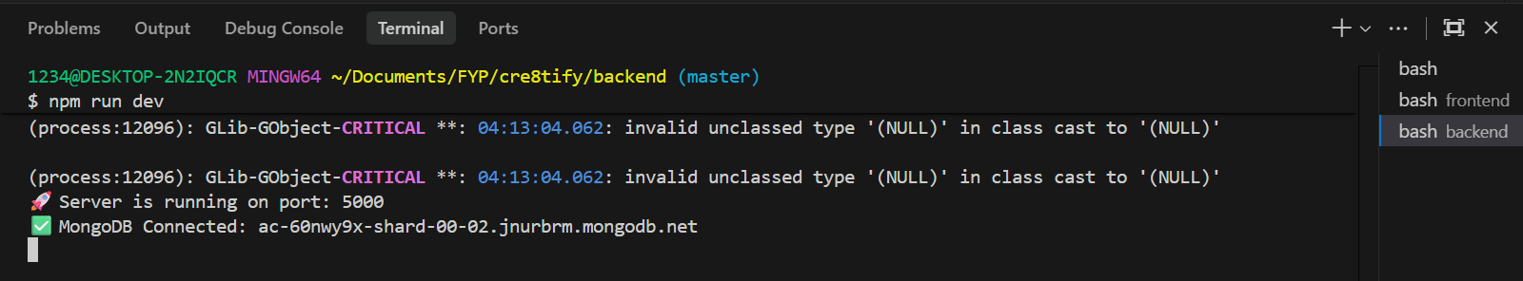
Figure A 3: Terminal (Frontend/Backend)

A.4 User Roles and Functionalities

The Cre8tify platform implements three major user roles within the system architecture.

Customer
Customers can browse collections, customize T-shirt designs, utilize Live Preview and 360° visualization functionalities, add products to cart, and complete sandbox purchase workflows.

Designer
Designers are able to create custom apparel products using the integrated Design Tool, upload products, manage their portfolio, monitor earnings, and track approval statuses through the Designer Dashboard.

Administrator
Administrators maintain marketplace quality through approval and rejection workflows, order monitoring, content moderation, and dashboard management operations.

A.5 Main Features of the System
The core functionalities implemented within the Cre8tify platform include:
- Interactive Design Tool
- Live Preview Visualization
- 360° Dummy Preview
- Sandbox Payment Workflow
- Role-Based Dashboard Architecture
- Wishlist and Cart Management
- Product Approval and Moderation
- Order Tracking System
- Marketplace Product Management

ADD IMAGES
- Design Tool screenshot
- Live Preview screenshot
- Dashboard screenshot
- Sandbox payment screenshot
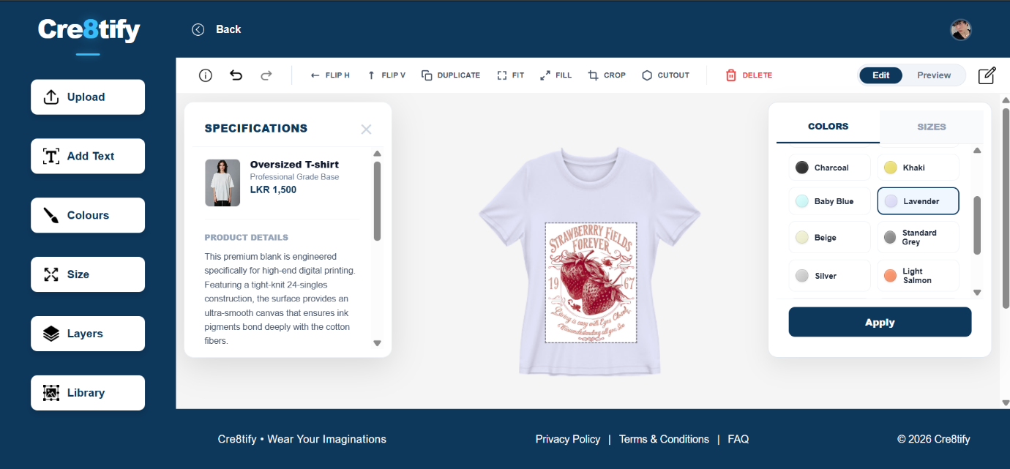
Figure A 4: Design Tool

A.6 Troubleshooting

Several troubleshooting procedures may assist users when technical issues occur during system setup or execution.
- Ensure all Node.js dependencies are installed successfully.
- Verify MongoDB connection configurations and environment variables.
- Confirm both frontend and backend servers are executed simultaneously.
- Use Google Chrome for optimal compatibility and rendering performance.
- Restart the Vite development server if styling updates fail to render correctly.

Appendix B – Project Source Code Link
The complete source code repository for the Cre8tify platform is available through the following GitHub repository:

GitHub Repository: https://github.com/dulniMahara/cre8tify

Appendix C – GitHub Commit History

The following commit history screenshots demonstrate the implementation progression and version control activities conducted throughout the development lifecycle of the Cre8tify platform. GitHub version control was utilized to maintain source-code stability, iterative feature development, and secure backup management.

ADD IMAGES
- 2–4 screenshots of commit history
- include timestamps + commit names

Appendix D – Other Supporting Materials

D.1 Preliminary Designs and Wireframes

The following preliminary interface designs and wireframes represent the early-stage conceptualization and user-interface planning activities conducted during the initial development phase of the Cre8tify platform.

ADD IMAGES
- Figma wireframes
- UI prototypes
- homepage concepts

D.2 System Architecture and Database Design

The following diagrams represent the technical architecture and database structure implemented within the Cre8tify platform.

ADD:
- ER Diagram
- Architecture Diagram
- Workflow Diagram
- Use Case Diagram

D.3 System Testing and Interface Validation

The following screenshots and evaluation outputs demonstrate testing procedures conducted throughout the implementation process, including interface validation, preview rendering, dashboard workflows, and order-processing functionalities.

ADD IMAGES
- Design Tool testing
- Live Preview testing
- Admin testing
- Order workflow
- Product approval workflow


PUSL3190 Computing Project

Project Initiation Document (PID)

Cre8tify Web Application

Supervisor: Miss Dharani Rajasinghe

Name: Mahara Mahara
Plymouth Index Number: 10952728
Degree Program: BSc (Hons) Software Engineering

Table of Contents

Chapter 01: Introduction………………………………………………………………………………………………………4
1.1. Background 4
1.2. Problem statement 4
1.3. Scope and limitations 4
1.4. Expected impact and stakeholders 5
Chapter 02: Business Case……………………………………………………………………………………………………6
2.1. Business Need 6
2.2. Business Objectives 6
Chapter 03: Project Objectives……………………………………………………………………………………………..7
3.1. Functional Deliverables 7
3.2. Quality Criteria 7
3.3. Success Metrics and Acceptance Criteria 7
3.3.1. Complete Customer Journey 7
3.3.2. Designer Portfolio Management 8
3.3.3. Administrative Control 8
Chapter 04: Literature Review………………………………………………………………………………………………9
Chapter 05: Method of Approach……………………………………………………………………………………….10
5.1. Research Design 10
5.2. Project Management Methodology 10
5.3. Algorithms, Tools and Frameworks 10
5.4. Data Sources and Collection Plan 11
5.5. Evaluation Metrics and Validation Strategy 11
Chapter 06: Conceptual Diagram………………………………………………………………………………………..12
6.1. Client-Side Application 12
6.2. Background Server 12
6.3. Data Layer (Storage Tier) 13
6.4. System Data Flow Scenario 13
Chapter 07: Initial Project Plan……………………………………………………………………………………………14
Chapter 08: Risk Analysis……………………………………………………………………………………………………15
8.1. Overview 15
8.2. Risk Assessment and Mitigation 15
8.3. Strategy for Technical Stability 16
References………………………………………………………………………………………………………………………….17

List of Figures

Figure 1 : High Level Architectural Diagram 13
Figure 2: Gantt Chart 14

List of Tables

Table 1 15

Chapter 01: Introduction

1.1. Background

In the recent years, there’s a significant rise towards online shopping and personalized products. This global shift is evidenced by the custom apparel market's projected growth of over $2.45 billion by 2029, driven by increasing smartphone penetration and consumer desire for unique garments (Technavio, 2025). With that, digital platforms have become an essential medium for both consumers and creators to connect and collaborate. Mainly this occurred in the fashion industry, where individuals prefer unique designs that reflect their personal style while creative local designers wish to showcase their artworks. As a result, “Cre8tify” sits as the intersection between these trends, providing a web-based, mobile responsive e-commerce platform specially developed focusing on Sri Lankan custom apparel market, which generated over $636 million in 2024 and continues to grow at an annual rate of 15-20% (ECDB, 2024).

1.2. Problem statement

Focusing on designing platforms, there are few existing platforms like “Printify”, “Redbubble” and “Teespring” but they lack localized features specially for beginners of our country and most of them are developed for international markets. Furthermore, Sri Lankan beginner designers face difficulties when it comes to monetizing their creativity due to payment limitations like PayPal, technical complexity and absence of beginner-friendly systems (Fernando et al., 2020; Siriwimala & Liyanage, 2021). Similarly, buyers do often lack trust and confidence when it comes to online shopping, as they cannot preview or try on them virtually. Recent studies highlight that a major obstacle to online apparel purchasing is the inability to physically inspect or try on products, which increases perceived risk (Hasan & Nguyen, 2025; Zhang et al., 2019). Therefore, these challenges highlighted the need of creating a designer-buyer friendly localized digital platform mainly focusing on Sri Lankans combining custom designing and preview functionality.

1.3. Scope and limitations

Cre8tify’s scope is on T-shirt designing and purchasing them for men, women and kids. Our system includes three main user roles such as, customer (buyer), designer and admin. Here, customers can browse, preview, customize and purchase designs or the full t-shirt. Designers can create designs using our tool kit or simply upload designs, set prices and manage their portfolio. Admin is responsible for handling and managing accounts, design approvals and payment verification. For customers, we’ll be implementing dual preview options, “Live Preview” (limited to front-view) where user uploads their image and visualize the t-shirt design they chose which is a unique feature in our application. And the other option is a “Dummy Preview” (3D model) allowing a 360° rotation displaying the design from all the sides. These will be handled ethically protecting customer’s privacy. Unlike Printify, Cre8tify uses local payment options (bank transfer/Sandbox) and is a web based, mobile responsive application.

The prototype is strictly limited to t-shirt apparel and will not be deployed on full-scale production infrastructure.

1.4. Expected impact and stakeholders

The project aims to create a user-friendly web-based application for consumers and designers that allows users to purchase locally crafted products and provide local artists opportunities to sell their work globally. Below are the prospective positive impacts/benefits to different stakeholder groups along with the core deliverables of this platform:

- Platform Deliverables

- Development of a "Live Design Preview" functionality that provides reassurance to consumers prior to purchasing a product.

- Integration of a “Secure Local Payment Method” to eliminate the barriers caused by the limitations of international payment methods.

- A Responsive Web Based Interface, designed to be compatible with desktop computers and mobile devices.

- Stakeholder Benefits

- Consumers: having a personalized shopping experience allowing them to customize, design and purchase clothing items with confidence.

- Designers: having access to an easy-to-use system for displaying their designs, operating an online store and monetizing their creative work.

- Administrators: get to oversee a central database which includes a Role-Based Access Control (RBAC) system to manage, monitor and regulate the marketplace and e-commerce systems.

- Ecosystem Benefit

By providing local alternatives to global design platforms, you are supporting the development of Sri Lanka’s digital economy.

Chapter 02: Business Case

2.1. Business Need

Currently, Sri Lankan designers must go through a complex workflow in order to design and sell their design works from websites like “Printify”. The main challenges faced by local users from such platforms are: Payment Issues, since most of these websites are focusing global market, they use “PayPal” as the payment gateway. And since Sri Lanka doesn’t fully support PayPal for receiving funds, local designers face a significant barrier on monetizing their work.

The next is Accessibility and Cost, mostly these kind of platforms aren’t free to use from start to end. They require paid subscriptions or third-party integrations like Etsy to build a marketplace.

They can’t directly engage with customers and sell their products. On the customers side, they prefer to see how a design would look on them before purchase. But most websites don’t let you “virtually try on” a cloth. Therefore, Cre8tify solves all these issues by being a local platform that has free preview tools and uses Sri Lankan payment gateways.

2.2. Business Objectives

The primary business objectives of “Cre8tify” is to provide a user-friendly market place for our beginner Sri Lankan designers, where they can easily deal with local payment methods (Bank Transfer/Sandbox).

In order to improve customer confidence and satisfaction, a “Live Preview” limited to only front view and a 360 degree -3D Dummy Model will be implemented. Also, customers not only get to just preview and purchase, if they wish they can interact with the specific designer and request for a customization. Orelse, customers are allowed with independent customizations via a built-in toolkit if the original designer has allowed that option.

Our website will be fully free, so no user is facing difficulties. Specially targeting on university students and young creative enthusiasts, providing them with a legitimate avenue for part time income generation will be a great step.

At the end we expect to integrate an earnings and sales tracking dashboard as well, so the designers get to analyze their business growth and improve their work over time.

Chapter 03: Project Objectives

The main goal of this project is to develop a fully functional prototype of the “Cre8tify” web application. The specific project-level objectives are listed as below:

3.1. Functional Deliverables

- Interactive web user interface: to create a mobile responsive web application using the React framework and ensuring that it is easy to access on both desktop and mobile devices.

- Live Preview and 3D Visualization Engine Integration: the implementation of a "Live Preview" capability using image processing methodologies to allow users to see what their designs will look like on an uploaded front-facing photo and secondly, the creation of a 3D model that allows 360° viewing of one complete design for the full view of the apparel design.

- Role Based Dashboards: to create secure dashboards with separate user interfaces for Customers, Designers and Administrators to manage their individual activities.

- Secure Payment Module: developing a simulated payment gateway (Sandbox / Bank Transfer) specifically for the Sri Lankan context.

3.2. Quality Criteria

In order to ensure the system meets academic and professional standards, there are quality goals which are being set. Firstly, the application must be responsive maintaining a consistent layout and functionalities across various screens, Desktop, Mobile, Tablet etc. Next, the performance with high-resolution design previews and 3D models that will load smoothly within a maximum of 3-5 seconds to maintain continuous user engagement. Lastly, the main part which is the user experience (UX). The system aims to provide with a full clean and intuitive interface which allows users to navigate features without prior training. In order to ensure that the design is effective, I will conduct a usability testing with a group of peers. My goal is to confirm that users can complete the main tasks like designing a T-shirt or using the designer dashboard without any assistance or confusion.

3.3. Success Metrics and Acceptance Criteria

The below mentioned criteria will help to identify if the project is considered successful.

3.3.1. Complete Customer Journey

This ensures that all the application’s components work together to provide a reliable end to end experience for the customer.
- Success metric: all the test users must be able to purchase products from browsing through our website to ordering and purchase confirmation without any system failure.

- Acceptance Criteria: when it comes to browsing, the “Women Collection” must load and display at least 6 products with the actual information. During Live Preview, customers must be able to upload a .jpg or .png file and check a chosen designed product overlayed on themselves. Lastly, the system must generate a valid “Order Confirmation” message after a simulated checkout. Same must happen with the other two collections as well.

3.3.2. Designer Portfolio Management

This ensures that the designer dashboard is functional and successfully connected with the database.

- Success metric: designers can successfully open up their store by uploading and pricing their work in our website, populate and view their portfolio within the system.

- Acceptance Criteria: a designer can login in, use the designing tool kit and upload a pre-made design or create real time, name the work, set price and preview. Then that design will immediately be added on “My Design” dashboard with a “Pending Approval” status of the admin. Also, the dashboard will provide an accurate sales and earnings based on simulated purchase data under “My Sales”.

3.3.3. Administrative Control

It’s all about the security and quality control, proving that Admin has the final say over what appears on the websites, avoiding designs that encourage violence, low quality designs and inappropriate wordings from being sold.

- Success Metric: only the administrator can change the product visibility on the public store.

- Acceptance Criteria: via the dedicated panel, Admin can approve or reject the designs submitted by the designers. If rejected, admin can submit a reasoning note as well. The approved designs become visible in the public store within 3-5 seconds of the status change. Regarding the security, users with a “Customer” role are restricted from accessing Designer or Admin only routes.

Chapter 04: Literature Review

One of the main disadvantages of online shopping is that they rely on 2D images. Literature like (Özbek, 2020) has shown that 2D images have failed in showing the true texture, design and quality of the products which leads to customer disappointment and high product return rates like 68% in the apparel industry. Researches like MYCloth (Liu & Wang, 2024) hence highlights that 3D models allow for “Intelligent interaction”. When a user is able to rotate a product 360 degrees, they will gain their trust in the products before they even touch it. Thereby, Cre8tify will be offering not only a 360 degree Dummy Preview, but also a “Live Preview” which is limited to front view. In Live Preview, customers will be asked to share a front facing image of them and next they will see the product fitted nicely onto them virtually.

The next uprising issue in Sri Lankan E-commerce is the “Digital Divide”. Global platforms like “Printify” and “Redbubble” are designed for Western economies. Research into Sri Lankan SMEs (Small and Medium Enterprises) depicts that “Payment Infrastructure” is the #1 barrier to digital adoption. Here, mainly what blocks young designers from engaging with the global market is, high bank fees for international gateways and the lack of support for local currency reception via providers like PayPal. As a result, Cre8tify will hold hands with “Localized Marketplace” by offering a free, well featuring designing platform with simple payment gateways like direct “Bank Transfers” and “Sandbox”.

According to studies, it had been identified that modern consumers (especially Gen Z) no longer want to just buy clothes but have a unique identification on their clothes. Some even prefer to design it themselves. Academic studies on “Consumer Co-creation” suggested that when a customer uses a toolkit for designing their own t-shirt, they perceive the product quality value more since they are investing their creativity, effort and new ideas into it. Because of that, Cre8tify allows both professional designer and individual customer to design t-shirts in our platform. While customers cannot sell them directly unless they register a formal shop in our platform, they can have those unique designs for themselves.

Chapter 05: Method of Approach

5.1. Research Design

Rather than a purely experimental study, this project adopts a prototype-based research design focusing on developing a functional, high fidelity web application. This is to demonstrate how localized features such as 3D previews and Sri Lankan payment methods can solve the e-commerce issues as mentioned earlier. The research involves an iterative process of designing, building and evaluating the platform’s effectiveness for its target stakeholders.

5.2. Project Management Methodology

To oversee the development of “Cre8tify”, I will utilize the “Agile Scrum Methodology”, which will facilitate my ability to conduct incremental and flexible development in two week sprints.

- Sprint 1 (Foundation) – Create the React environment and develop responsive Frontend Components such as Sidebar and Navigation.

- Sprint 2 (Core Logic) – Build both Designer and Admin Dashboards and connect to MongoDB.

- Sprint 3 (Interactive Features) – Add Third-Party Library (Three.js) to create a dummy Image that can be rotated 360 degrees and develop Live Preview Overlay Functionality.

- Sprint 4 (Integration and Testing) – Complete Payment Sandbox and perform Usability Testing with Colleagues.

5.3. Algorithms, Tools and Frameworks

For my system I have decided to follow the “MERN” stack since it is an industry standard collection and perfect for my web application.

- Frontend (React.js v18) – this is used with the aim of building a fast, single page application (SPA) that ensures the interface remains “visually appealing and user friendly” avoiding constant page reloads.

- 3D Virtual Engine (Three.js) – this is a WebGL based library used for rendering and rotating the 3D dummy model allowing a 360 degree visualization.

- Backend (Node.js and Express.js) – this handles all the server side logic, API routing and secure communication between the frontend and database.

- Database (MongoDB) – used for storing all flexible data structures like user profiles, design metadata and the order records.

- Image Overlay Algorithm – a custom script will be developed in order to dynamically position and scale user-uploaded designs onto t-shirt templates for “Live Preview” feature.

5.4. Data Sources and Collection Plan

As for the primary data I will be collecting feedbacks from 5-10 peers through usability testing to confirm the UI/UX. For secondary data, a collection of 20-30 high quality apparel templates and design assets will be sourced to populate the initial marketplace. Cre8tify ensures to take care on “Privacy Considerations” therefore, following the standard data and protection ethics, the system is developed to process these files locally within the session. The images will not be stored permanently unless user consent.

5.5. Evaluation Metrics and Validation Strategy

The success of technical approach will be measured through two tier validation strategy:

- System Validation – utilizing functional testing to ensure Role Based Access Control (RBAC) is operational allowing the system to check whether the users are logged into their correct role base and recognize what they are allowed to do. Also, during “Sandbox” payment, the test will ensure when user pays and creates a proper digital receipt for the order.

- User Validation – conducting a User Acceptance Test (UAT), where participants are given a specific task like to complete a design and visualize it using the Preview options. Our system is considered successful if the preview is loaded smoothly within 3-5 seconds of a timeframe.

Chapter 06: Conceptual Diagram

Cre8tify platform utilize a three-tier architecture designed for a seamless user experience across different roles. The architecture is divided as:

- Client-side layer
- Backend server layer
- Data storage layer

6.1. Client-Side Application

Cre8tify’s frontend is built using React.js and TypeScript ensuring to provide a responsive and interactive interface for the primary users, customers, designers and admins.

- Role-Based Dashboards: Tailored interfaces for Customers (discovery), Designers (shop management), and Admins (platform oversight).
- Interactive Preview Studio: A core feature allowing users to visualize designs via a 360° dummy preview or a front-facing AR live preview using uploaded personal images.
- Order Tracking Interface: Provides real-time updates on the production and delivery status of customized apparel.

6.2. Background Server

The background server will serve as the brain of the service by taking care of all heavy lifting functions (such as image processing, live preview etc.) due to the visual logic engine and the services' ability to calculate. The logic layer of the service is built with Node.js.

- API Gateway (Authentication): Provides and manages a secure channel of communication with customers who need to gain access to the service and implements Role-Based Access Control (RBAC) to restrict who can see what data.

- Visual Logic Engine (Blend Mode): A purpose-built service that implements the "Multiply" blend mode that allows for the application of dynamic colors to the base t-shirt PNGs but keeps the texture and design of the original item intact.

- Order Logic & Notification Service (Order Processing): Orchestrates the calculations regarding pricing (Base Price + Designer Price + Service Charges) and manages the workflow of "Designer Edit" requests.

6.3. Data Layer (Storage Tier)
To optimize performance, the system separates structured metadata from heavy media assets.
- Relational Database (SQL): Stores structured information including user credentials, product metadata for the Women/Men/Kids collections, transaction logs, and customer reviews.
- Cloud Asset Storage: A dedicated object storage system for high-resolution T-shirt base images (front/back), customer-uploaded photos, and designer artwork.
- Asset URI Mapping: A dashed-line linkage ensures the SQL database can precisely fetch the correct image files from the asset storage based on user selection.

6.4. System Data Flow Scenario

When a customer chooses a color swatch for their t-shirt, the Client-Side Application sends an HTTPS request to the Backend Server. The Visual Logic Engine matches the chosen hex code with the light-grey base image from Asset Storage, then sends back the processed preview to the UI in real-time so that users can confirm their custom design prior to purchasing.

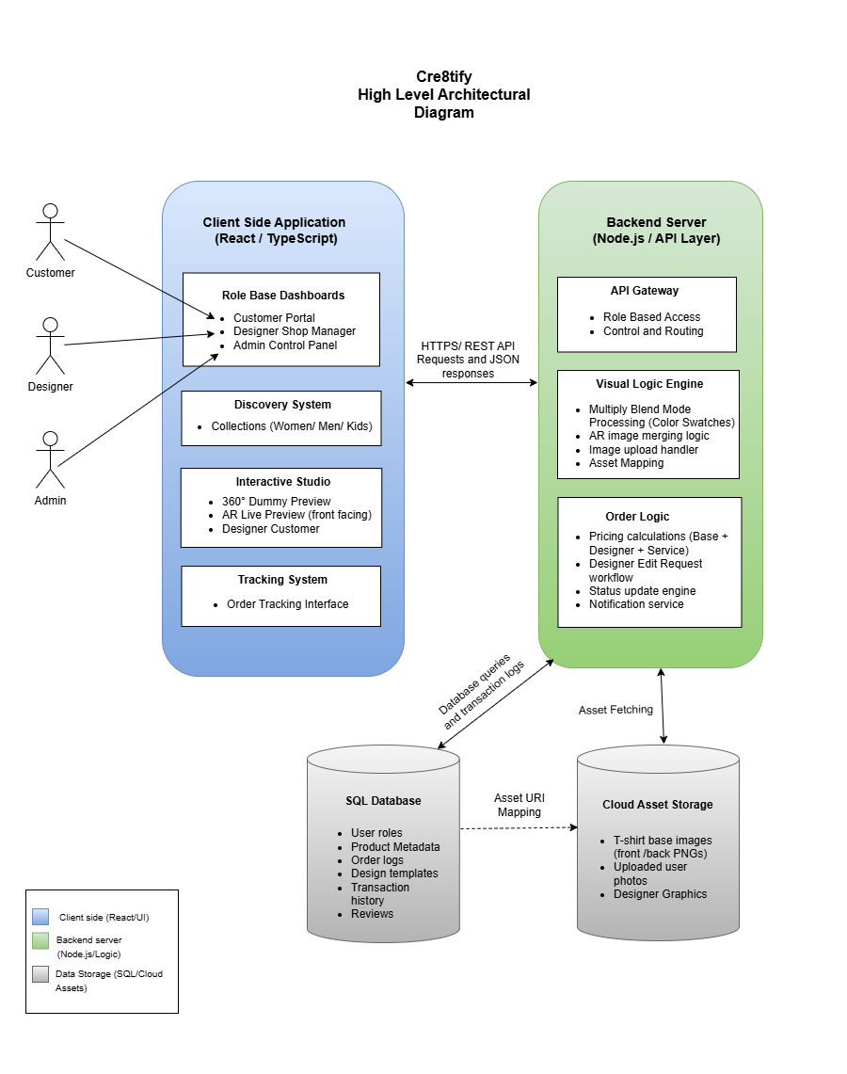
Figure 22 : High Level Architectural Diagram

Chapter 07: Initial Project Plan

Cre8tify has planned its roadmap leading through all phases of a developed application, starting with the “Planning phase” in which we define our system needs and create the High-Fidelity prototypes for our Women’s, Men's and Kids’ Collections in Figma.

It is followed by Sprint 1 – MVP Development, focusing on core engine features such as the dynamic color switching logic and the product detail interfaces. Sprint 2 (Advanced Features) then implements the high-complexity elements, specifically the front-facing AR live preview and the designer/admin management dashboards. The final weeks are dedicated to System Integration and Testing, ensuring that the order tracking service and user-uploaded design processing are stable before the final submission. This timeline prioritizes technical risks early to ensure all interactive customization tools are fully validated.
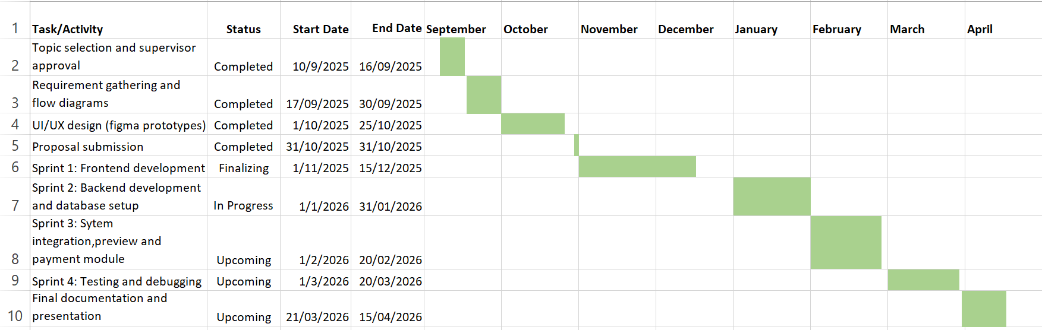
Figure 23: Gantt Chart

Chapter 08: Risk Analysis

8.1. Overview
The Cre8tify Project depends heavily on effective risk management to prevent technical, operational, or resource constraints from interfering with the project timeline or quality. Chapter 8 will list examples of potential threats to project success and offer guidelines for proactively limiting the effect of those threats.

8.2. Risk Assessment and Mitigation
Below is a table of the major risks grouped according to the probability of occurrence and the severity of the risk on core system capability.
Risk Category | Potential Impact | Likelihood | Mitigation Strategy
Technical Complexity | High | High | Prioritize the development of the CSS "Multiply" blend mode for a stable MVP before integrating advanced AR logic.
System Performance | Medium | Medium | Implement image optimization and lazy loading to ensure high-resolution T-shirt assets do not slow down the UI.
Data Privacy and Security | High | Low | Deploy Role-Based Access Control (RBAC) to secure customer-uploaded images and designer shop data.
Resource Availability | Medium | Low | Maintain automated cloud backups of the codebase and design assets to prevent data loss.
Scope Creep | Medium | Medium | Adhere strictly to the pre-defined features (Collections, Live Preview, and Tracking) to meet the final submission deadline.

Table Error! No text of specified style in document.-1

8.3. Strategy for Technical Stability
The most significant risk is the Real-time Visual Logic Engine, as any failure in image transparency or blending would render the "Live Preview" feature unusable. To mitigate this, the project adopts an "Iterative Testing" approach, where the blend mode logic is validated against various T-shirt base colors early in the development cycle. Furthermore, separating the Cloud Asset Storage from the SQL Database ensures that the high-frequency data used for order tracking remains fast and unaffected by heavy media files.

References
- ECDB (2024) Fashion - Sri Lanka | eCommerce market analysis. [online] Available at: https://ecommercedb.com/markets/lk/fashion (Accessed: 14 January 2026).
- Facebook Open Source (2025) React: A JavaScript library for building user interfaces. [online] Available at: https://reactjs.org/ (Accessed: 14 January 2026).
- Fernando, P., Silva, R. and Kumara, A. (2024) ‘Digital entrepreneurship in emerging economies: navigating payment and technical barriers in Sri Lanka’, Journal of Global Business Insights, 9(1), pp. 45-60.
- Google Developers (2025) Web Vitals: Essential metrics for a healthy site. [online] Available at: https://web.dev/vitals/ (Accessed: 14 January 2026).
- Hasan, R. and Nguyen, B. (2025) ‘Consumer trust and perceived risk in virtual fitting rooms’, Journal of Retailing and Consumer Services, 78, p. 103722. doi:10.1016/j.jretconser.2024.103722.
- Liu, J. and Wang, Y. (2024) ‘MYCloth: Intelligent interaction and 3D visualization in apparel e-commerce’, International Journal of Fashion Design, Technology and Education, 17(3), pp. 312-325.
- MDN Web Docs (2024) mix-blend-mode - CSS: Cascading Style Sheets. [online] Available at: https://developer.mozilla.org/en-US/docs/Web/CSS/mix-blend-mode (Accessed: 14 January 2026).
- Meta Platforms, Inc. (2026) React – A JavaScript library for building user interfaces. [online] Available at: https://react.dev/ (Accessed: 14 January 2026).
- Microsoft Corporation (2025) TypeScript Documentation: Typed JavaScript at Any Scale. [online] Available at: https://www.typescriptlang.org/ (Accessed: 14 January 2026).
- Node.js Foundation (2025) Node.js v20.x Documentation. [online] Available at: https://nodejs.org/docs/ (Accessed: 14 January 2026).
- Özbek, A. (2020) ‘Online customized T-shirt design and evaluation of online websites for customization’, Industria Textila, 71(4), pp. 371–379. [online] Available at: https://www.revistaindustriatextila.ro/images/2020/4/011%20AHMET%20%C3%96ZBEK_Industria%20Textila%204_2020.pdf (Accessed: 14 January 2026).
- Photopea (2026) Photopea Online Photo Editor. [online] Available at: https://www.photopea.com/ (Accessed: 14 January 2026).
- PostgreSQL Global Development Group (2025) PostgreSQL 16 Documentation. [online] Available at: https://www.postgresql.org/docs/ (Accessed: 14 January 2026).
- Printify (2026) Printify: Print on Demand & Drop Shipping Platform. [online] Available at: https://printify.com/ (Accessed: 14 January 2026).
- Redbubble (2026) Redbubble: Awesome products from independent artists. [online] Available at: https://www.redbubble.com/ (Accessed: 14 January 2026).
- Siriwimala, M. and Liyanage, S. (2021) ‘Technical barriers to e-commerce adoption among Sri Lankan creative professionals’, Sri Lanka Journal of Technology, 12(4), pp. 201-215. [online] Available at: https://www.sljt.lk/archive/ (Accessed: 14 January 2026).
- Small and Medium Enterprises Sri Lanka (2025) Digital adoption and payment infrastructure barriers for SMEs. [online] Available at: https://www.srilankasme.lk/reports/digital-adoption (Accessed: 14 January 2026).
- Technavio (2025) Custom Apparel Market - Global Forecast and Analysis 2025-2029. [online] Available at: https://www.technavio.com/report/custom-apparel-market-analysis (Accessed: 14 January 2026).
- Teespring (2026) Teespring: Free platform to create and sell. [online] Available at: https://teespring.com/ (Accessed: 14 January 2026).
- University of Manchester (2024) ‘Gen Z and the rise of Consumer Co-creation in digital fashion’, Creative Industries Research Hub. [online] Available at: https://www.manchester.ac.uk/research/ (Accessed: 14 January 2026).
- W3Schools (2025) CSS Filters Reference. [online] Available at: https://www.w3schools.com/cssref/css3_pr_filter.php (Accessed: 14 January 2026).
- Zhang, T., Lu, C. and Kizildag, M. (2019) ‘Banking on “What’s Hot”: Determinants of consumers’ use of fashion apps’, Journal of Consumer Marketing, 36(6), pp. 751-761.

Appendix F – Interim Report
The Interim Report submitted during the intermediate evaluation phase of the Cre8tify project is attached in this appendix section. The document includes system analysis, implementation progress, feasibility studies, and preliminary testing activities conducted during development.
✅ INSERT FULL INTERIM PDF HERE

Appendix G – Records of Supervisory Meetings
The following records summarize supervisory meetings conducted throughout the project lifecycle. Discussions included requirement analysis, implementation progress, technical feedback, testing observations, and report-writing guidance.

ADD:
- signed meeting forms
- progress tracking sheets
- supervisor comments
- weekly updates

